

VA Form 21P-530EZ

Application For Burial Benefits

Launched: April 2024  
Version 1 (modernized)

Revision History

| Date | Version | Description | Author |
| --- | --- | --- | --- |
| Unknown | 0 | The product debut did not feature a guide |  |
| 05/2024 | 1 | Creation of first product guide | Fiorella Geedi |

Table of Contents

**1. Overview**

**2. User Access**

**3. Navigation**

Main menu

How to apply: Link to application form[About form 530EZ](#HowtoApplyLinktoAppForm)

**4. Functionality**

Introduction page

Not signed in  
Signed in  
In-process  
Step 1: Your information

Step 2: Deceased Veteran information

Step 3: Military history

Step 4: Benefit selection

Step 5: Upload documents

Step 6: Review

Confirmation

**5. Major Issues and Error Messages**

Required response

Privacy policy

Missing information

[Submission failure  
Connection error](#ConnectionError)

## 1. Overview

The Veterans Burial Allowance online form (VA Form 21P-530EZ) enables a Veteran’s surviving spouse, partner, child, parent, executor, or estate administrator to apply for burial, plot, and transportation allowances.

## 2. User Access

Who can access this form?

* **Authenticated users:** Veteran’s surviving spouse, partner, child, parent, executor, or administrator of the Veteran’s estatewith a VA.gov account.
* **Unauthenticated users:** Veteran’s surviving spouse, partner, child, parent, executor, or administrator of the Veteran’s estate without a VA.gov account.

## 3. Navigation

How can claimants access this form?

Claimants access this form in the following ways on VA.gov:

* How to apply page: [https://www.va.gov/burials-memorials/Veterans-burial-allowance/](https://www.va.gov/burials-memorials/veterans-burial-allowance/)
* About form 21P-530EZ: <https://www.va.gov/find-forms/about-form-21p-530ez/>
* Online form: <https://www.va.gov/burials-and-memorials/application/530/introduction>
* Search results
* Direct links to the PDF of the form on VA.gov (available soon)

##### Main menu

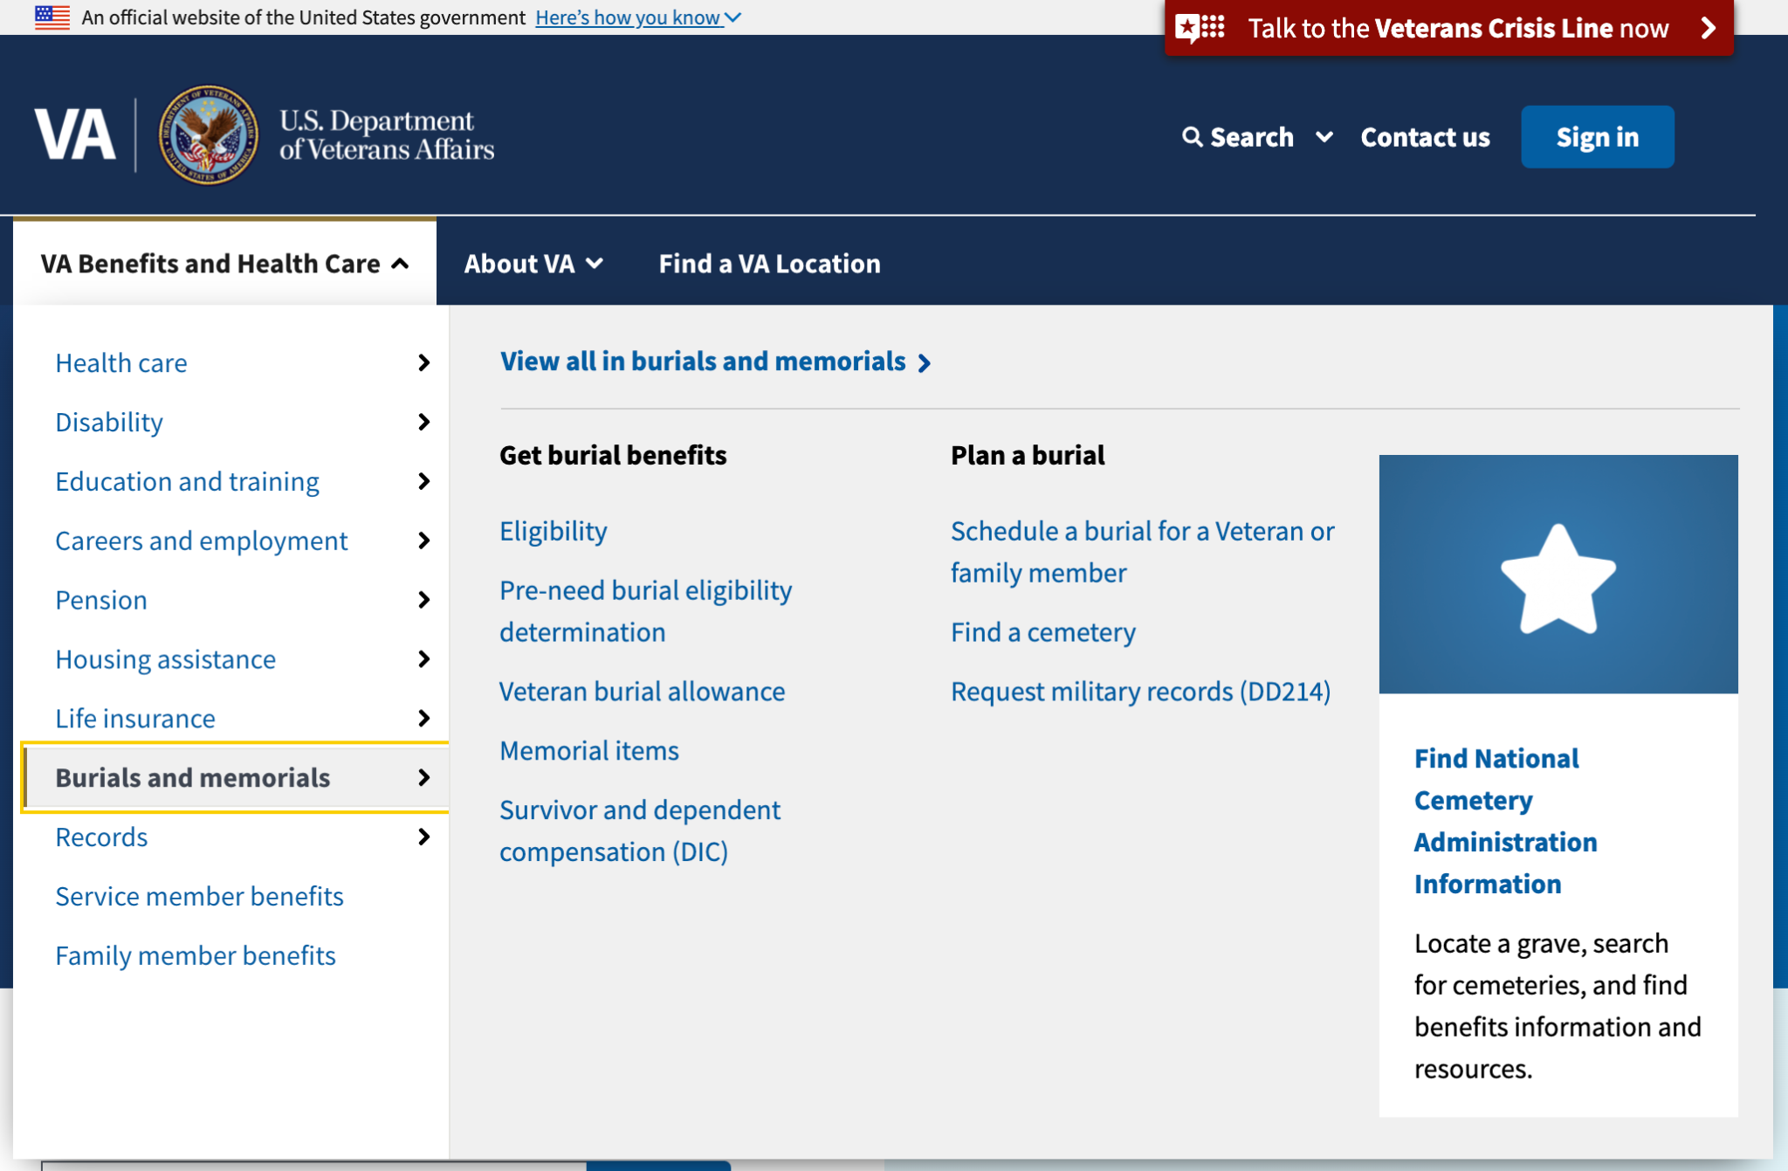

##### How to apply: Link to the application form

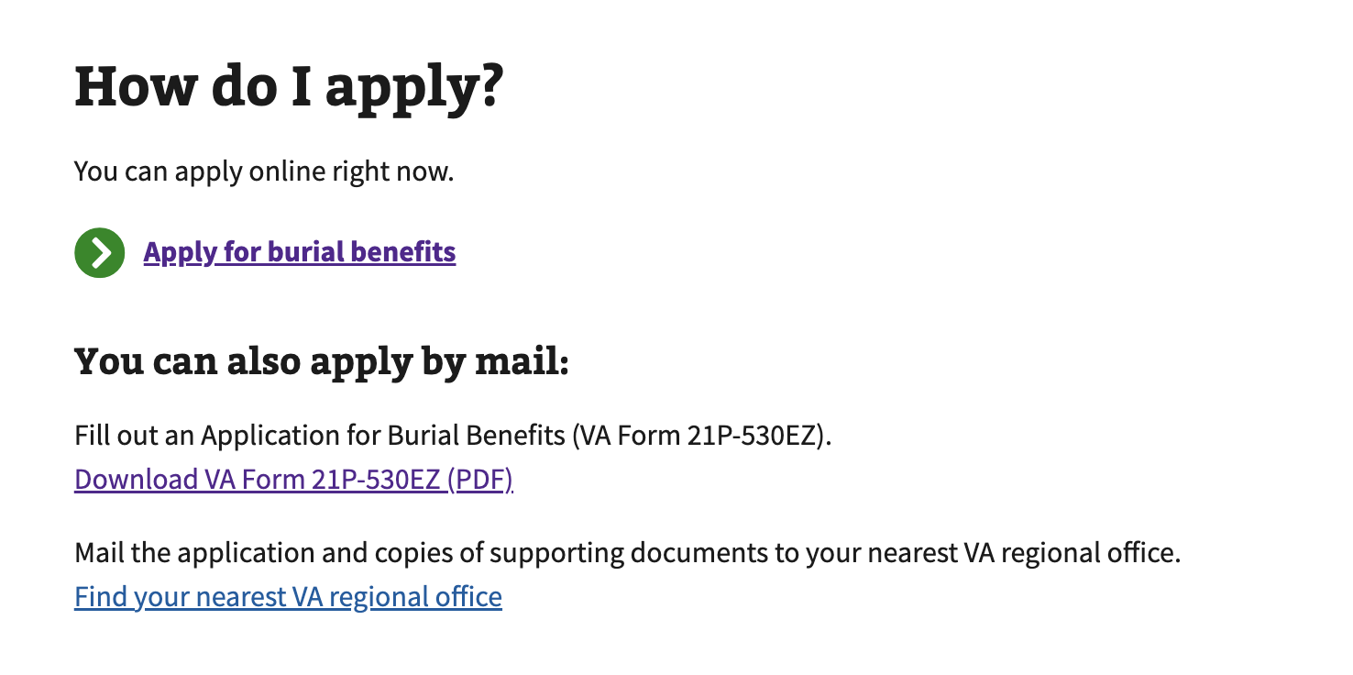

##### About form 21P-530EZ

Once the updated VA Form 21-P-530EZ is live, a direct link to the form will be available. A screenshot will illustrate the link location.

## 4. Functionality

Direct URL: <https://www.va.gov/burials-and-memorials/application/530/introduction>

### Introduction page

This page explains what is expected from the claimant. It lists the following:

* **Check eligibility**: Reminds the claimant to review the eligibility page before  
  they apply
* **Gather your information**: It lists all the information the claimant might need about the deceased Veteran
* **Apply**: Explains how long it should take
* **After you apply**: This section explains what happens after the claimant submits  
  the form

#### Not signed in

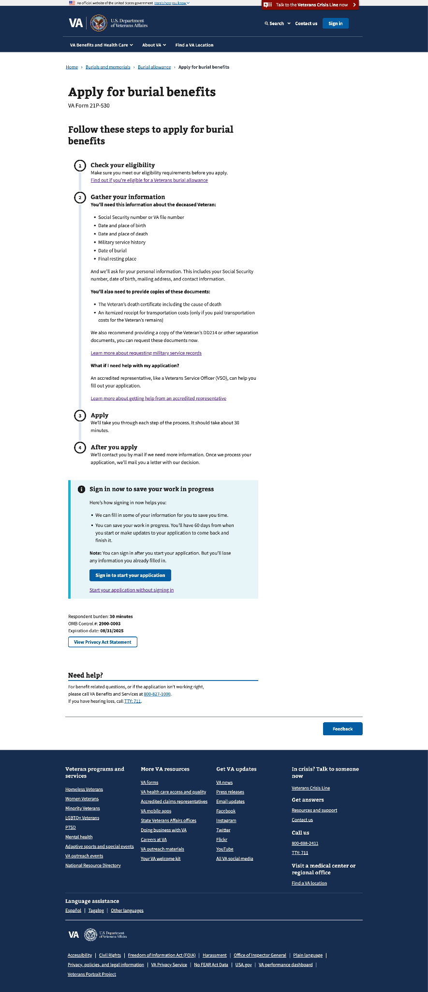

#### Signed in

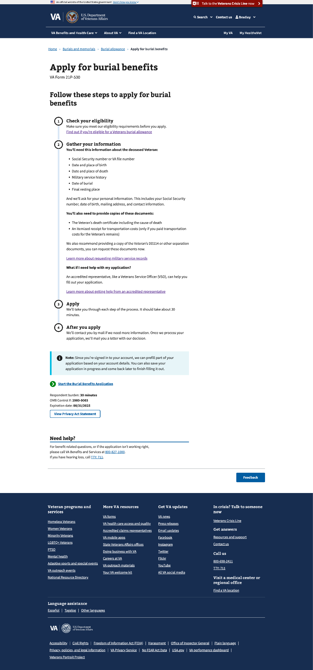

#### In-process

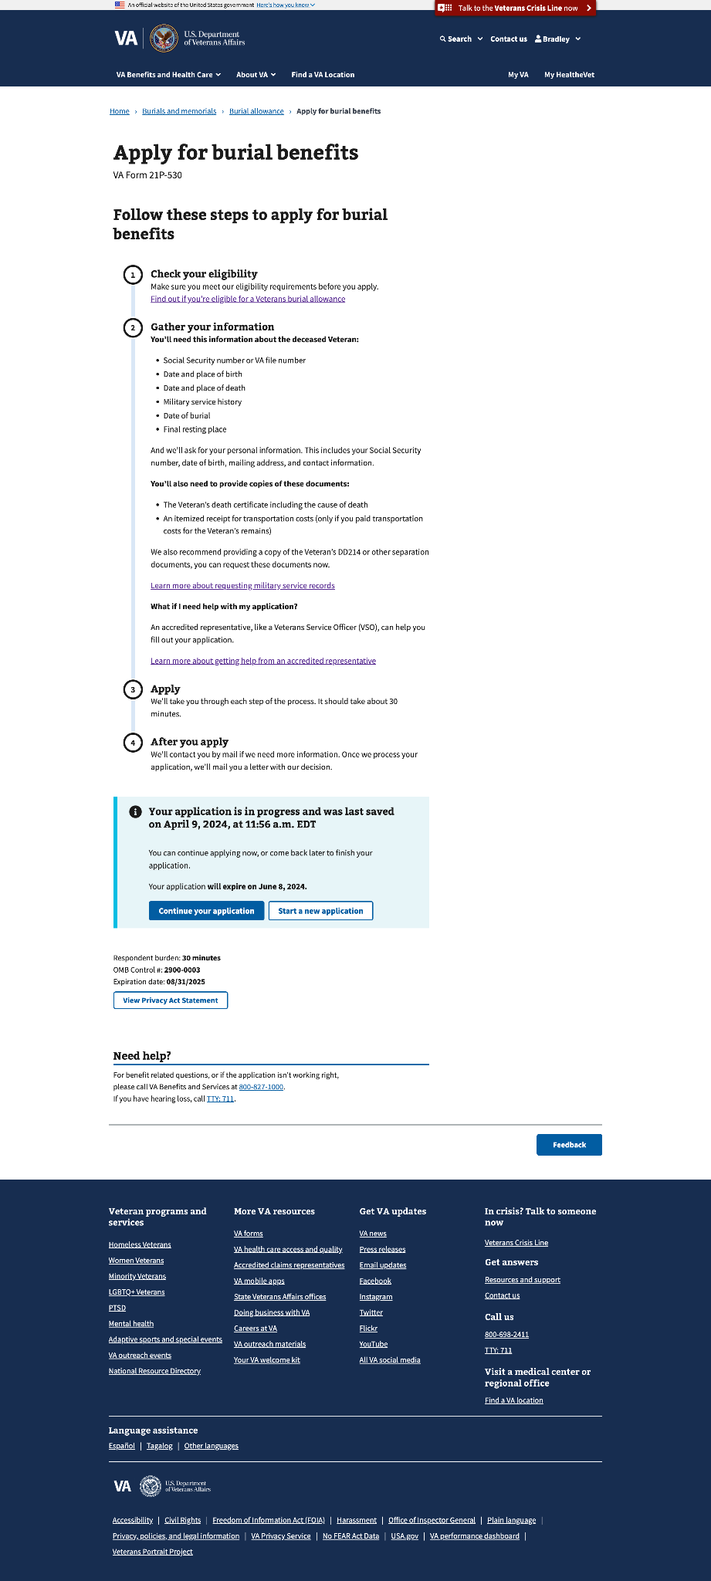

### Step 1: Your information

This step includes 4 sub-pages that ask for the claimant’s relationship to the Veteran, personal information, mailing address, and contact information.

#### 1.0 Relationship to Veteran

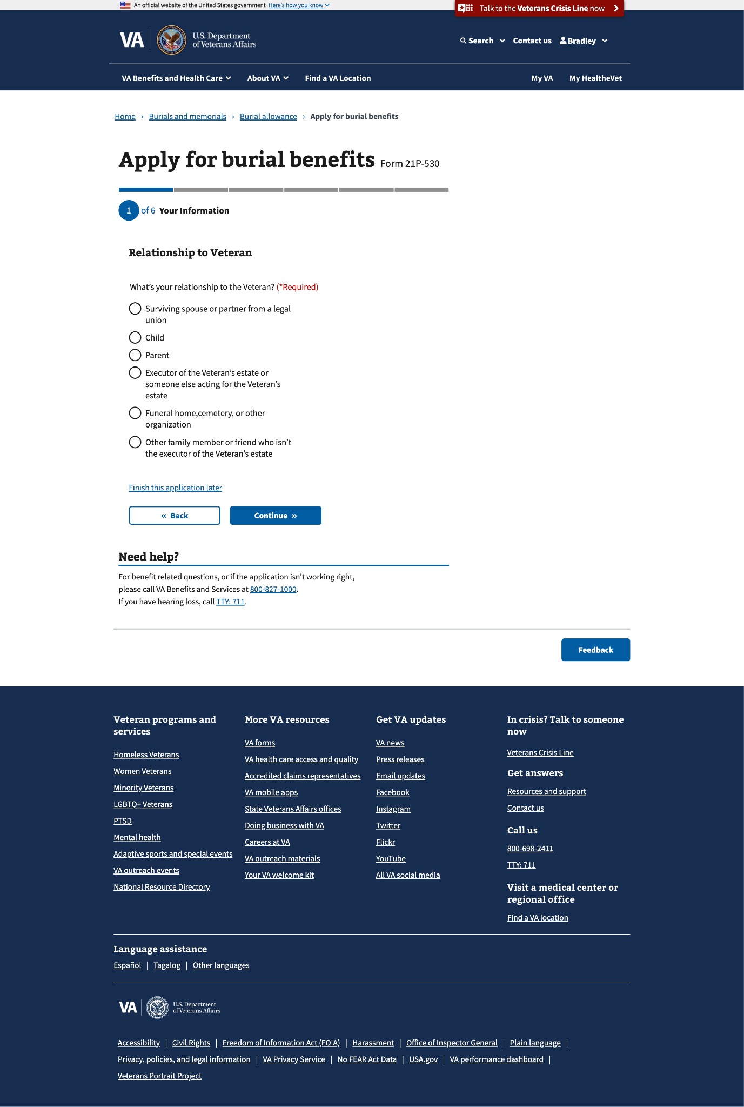

#### 1.1 Personal information

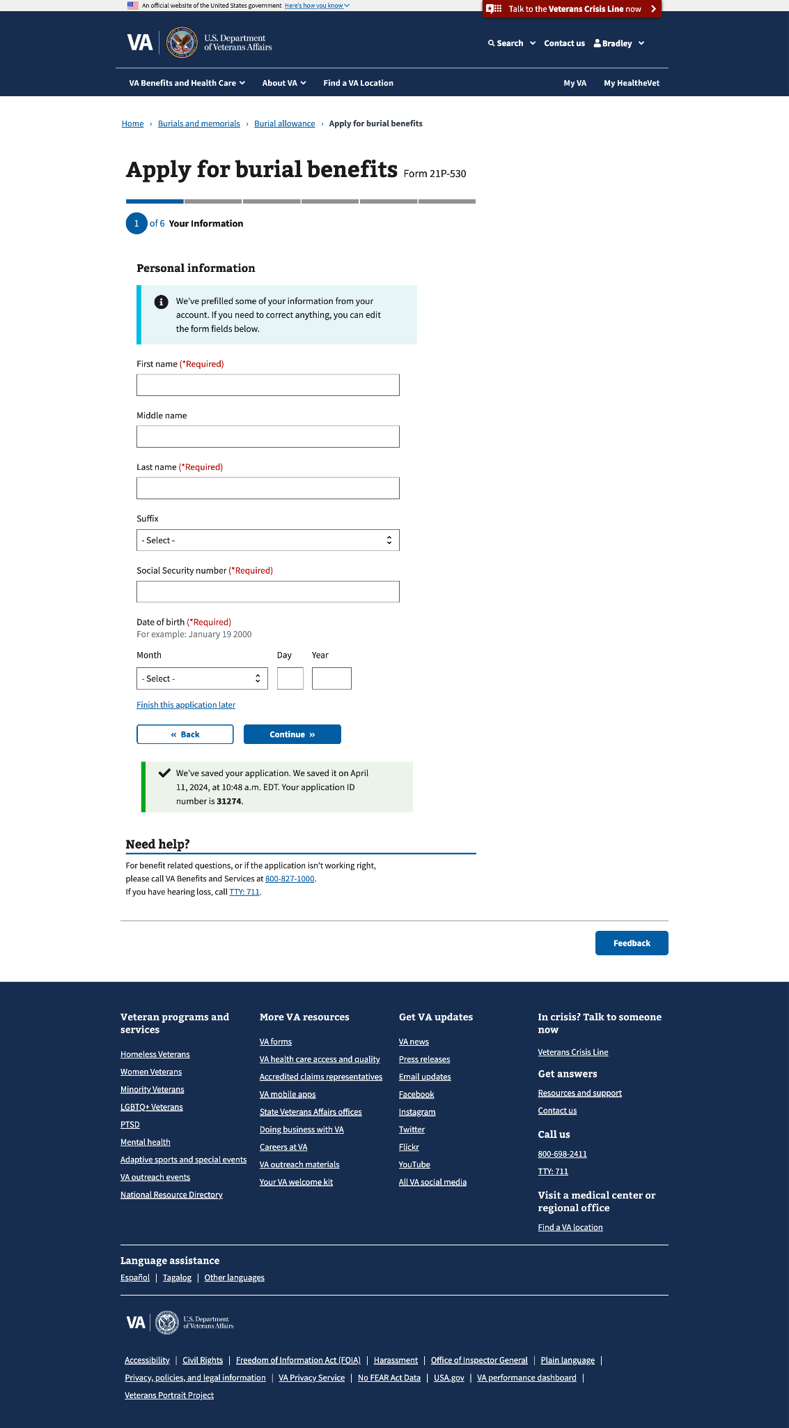

#### 1.2 Mailing address

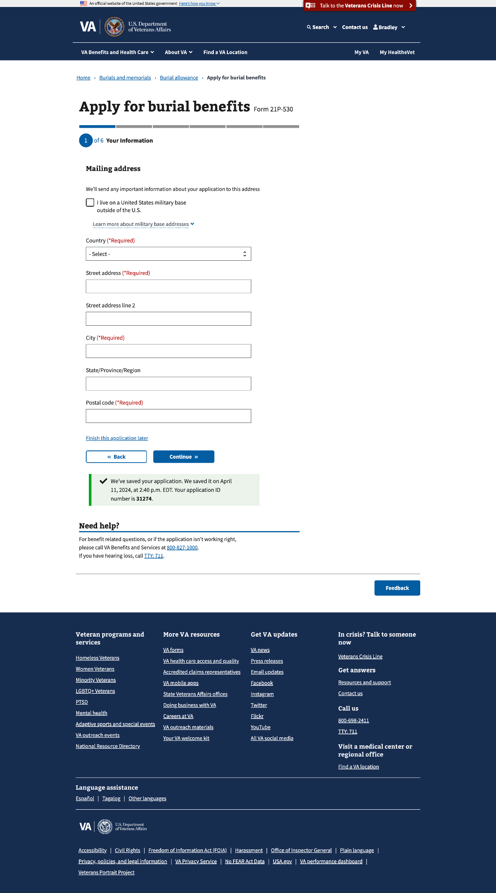

#### 1.2 Mailing address (outside the U.S.)

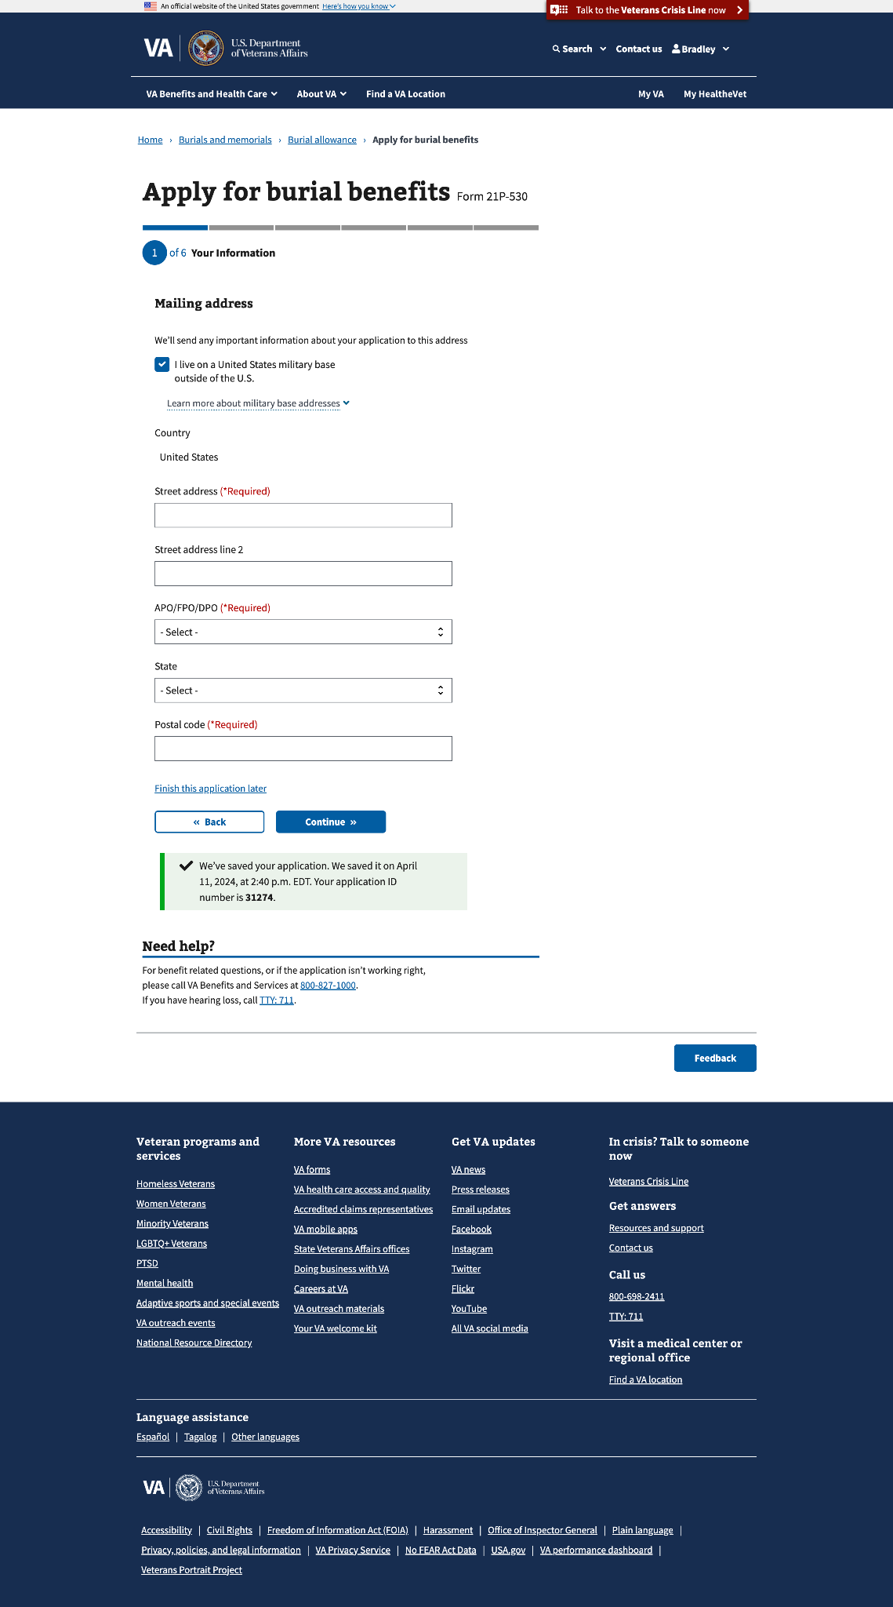

#### 1.3 Contact information

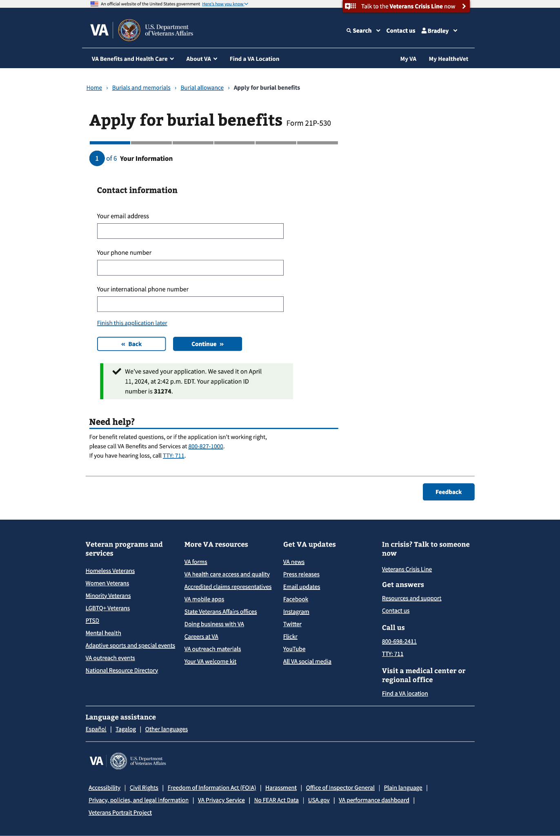

### Step 2: Deceased Veteran information

This step has 3 sub-pages that ask about the deceased Veteran’s personal information, burial dates, and death location.

#### 2.0 Veteran’s personal information

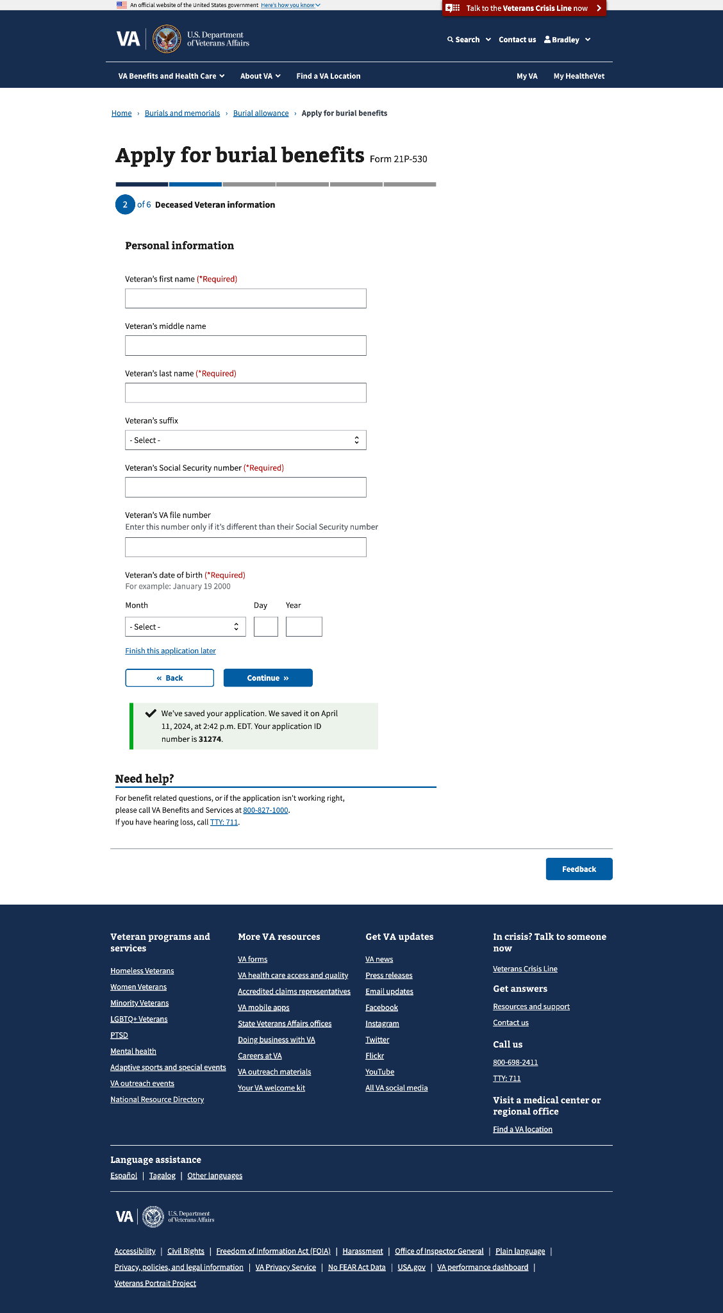

#### 2.1 Burial information

#### 

#### 2.2 Veteran death location

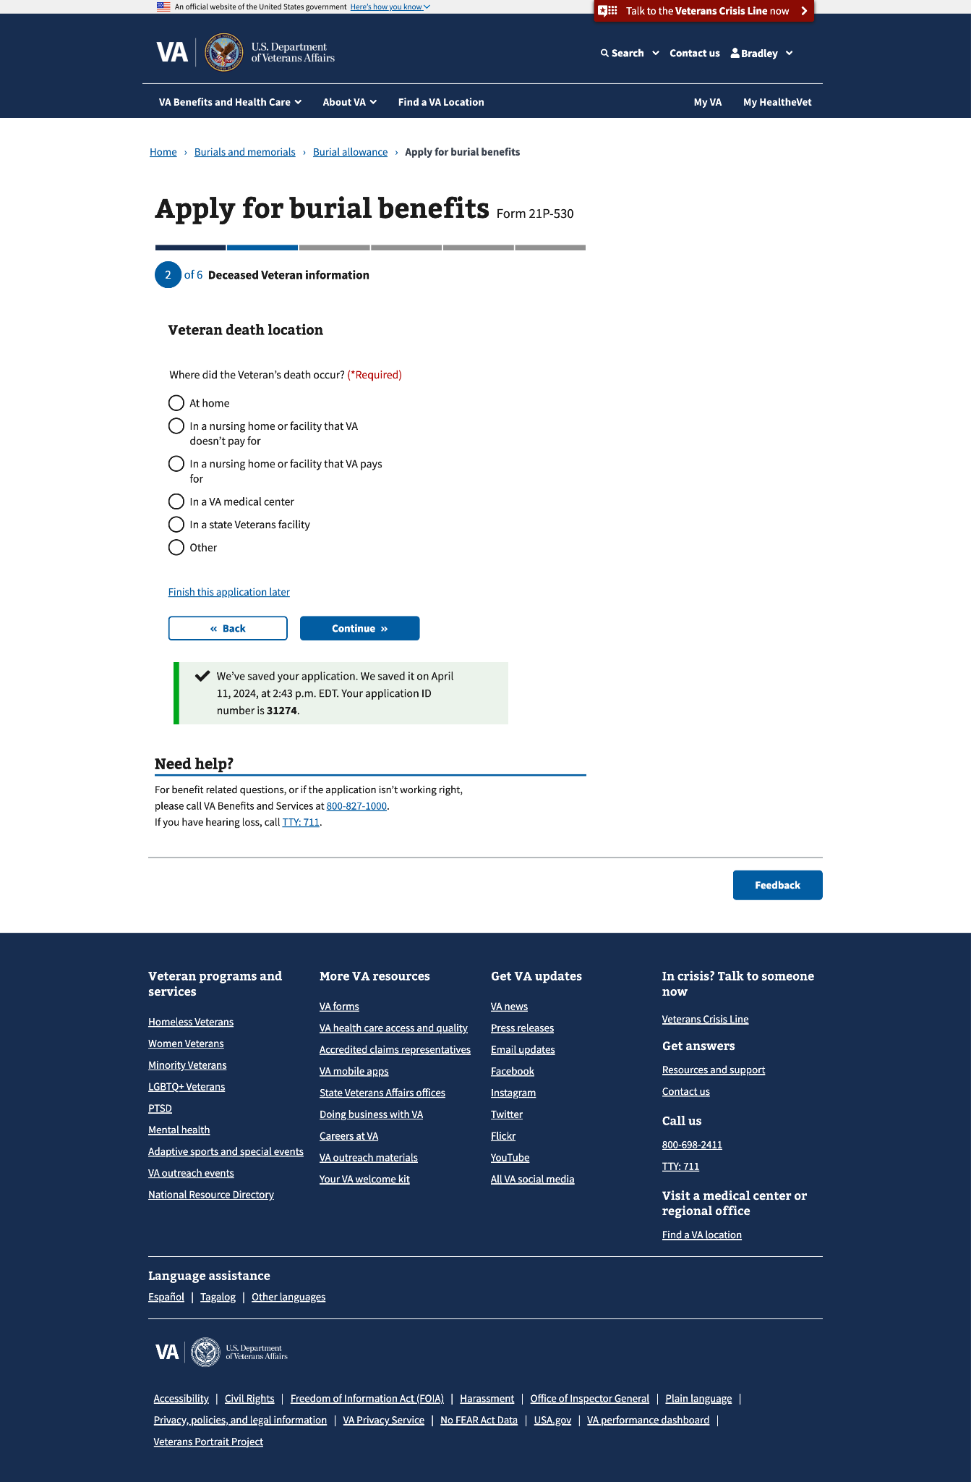

#### 

#### 2.2 Veteran death location - conditional fields

Conditional fields will appear when any of the options except at home is selected.

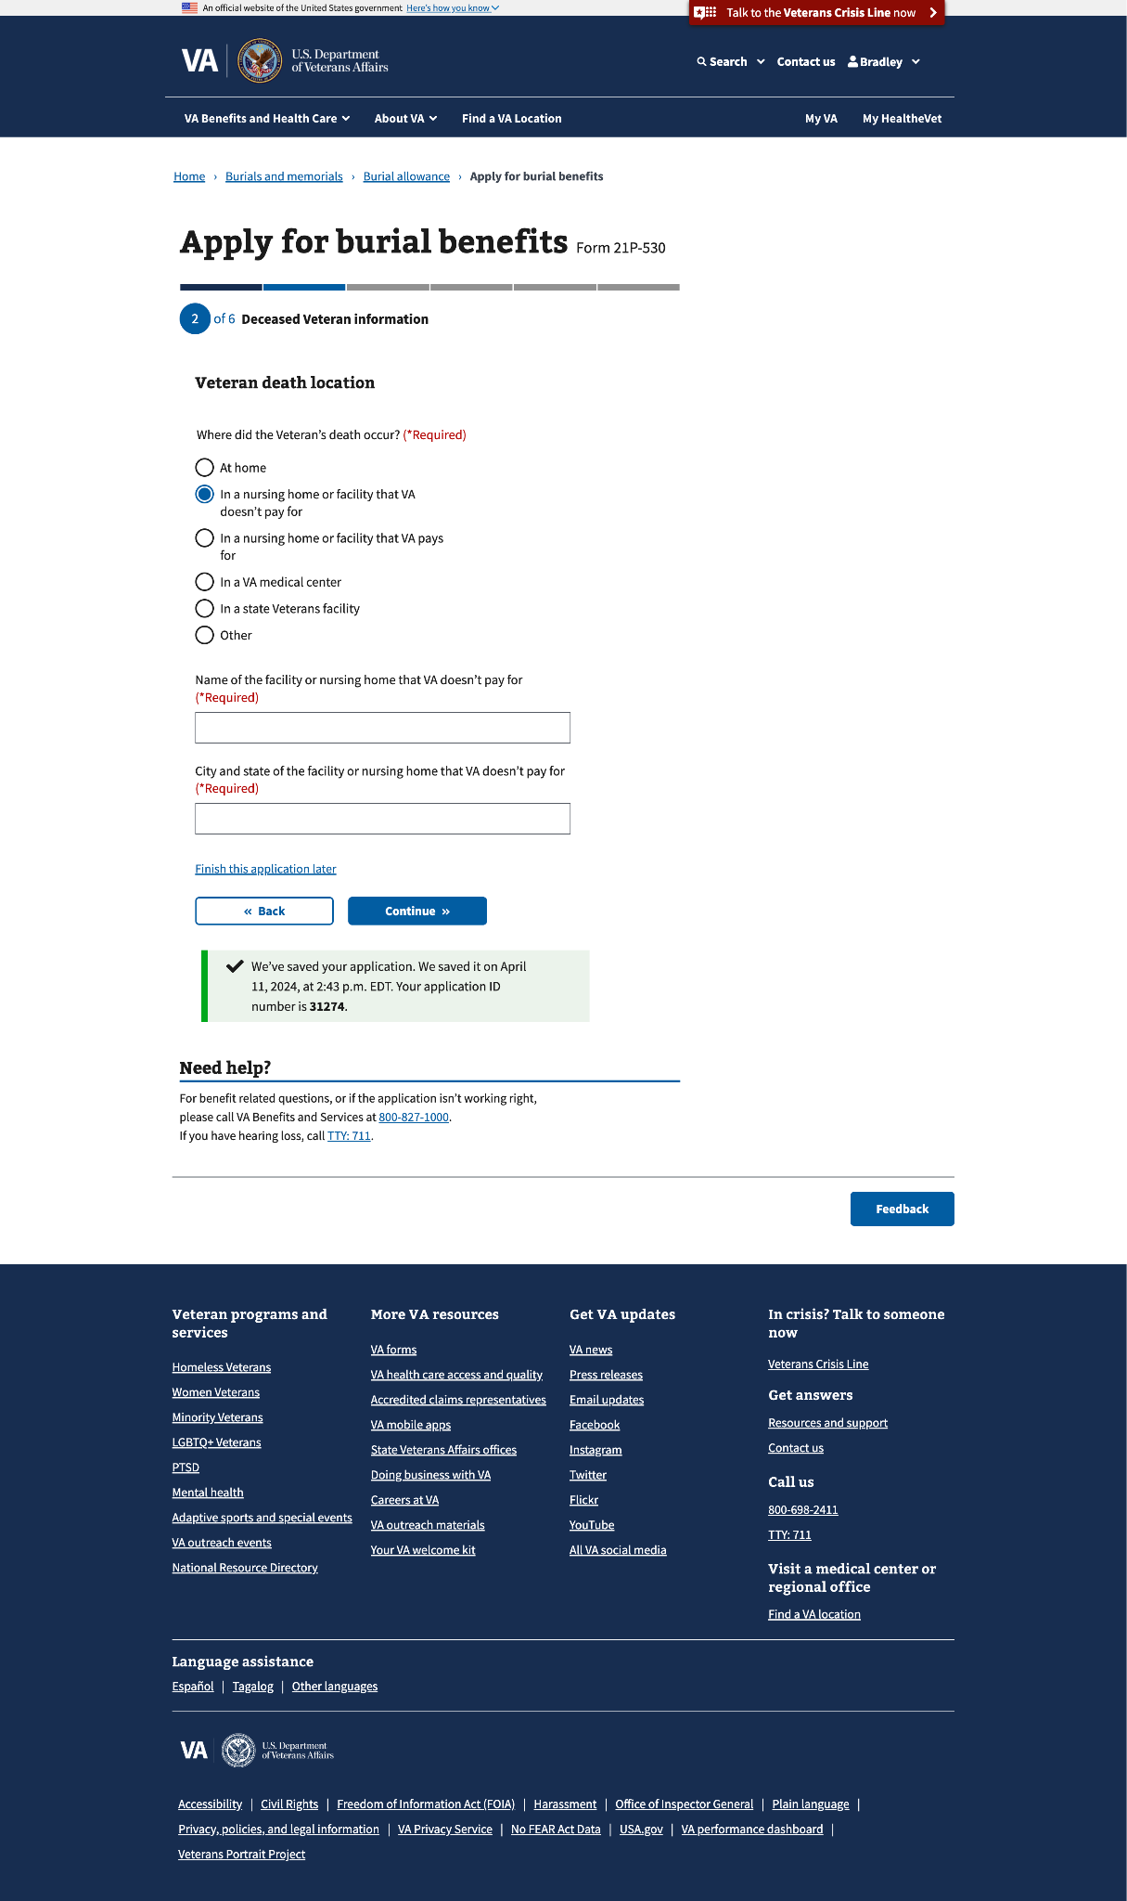

### Step 3: Military History

This step has 4 sub-pages that ask about the deceased Veteran’s military information and any previous name the Veteran had used during their service periods. If the claimant uploads a DD214, they will skip a page that asks about the Veteran’s  
service periods.

#### 3.0 DD214 or other separation documents

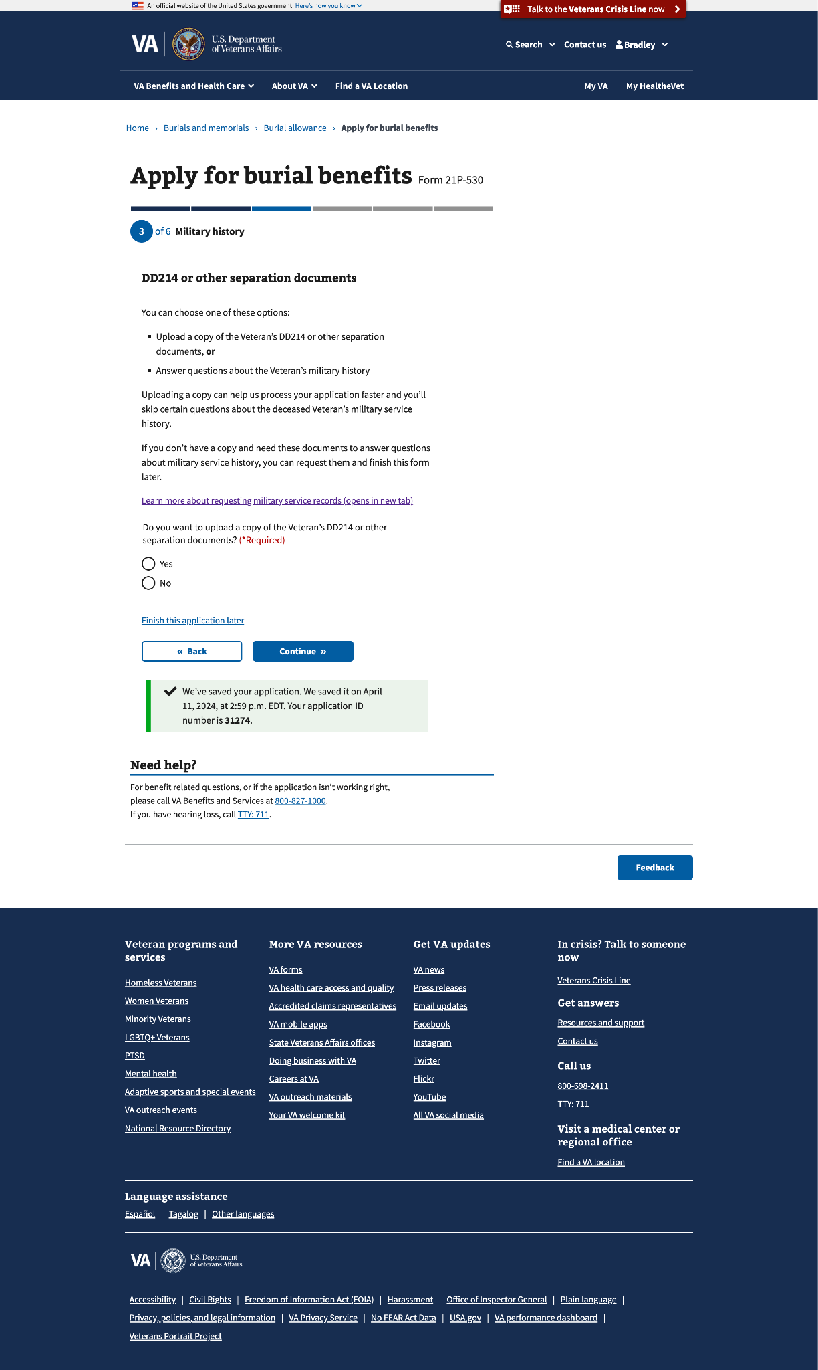

#### 3.1 DD214 or other separation documents (upload screen)

This page will appear if the claimant selects “Yes” to the “Do you want to upload a copy of the Veteran’s DD214 or other separation documents?” question on the  
previous screen.

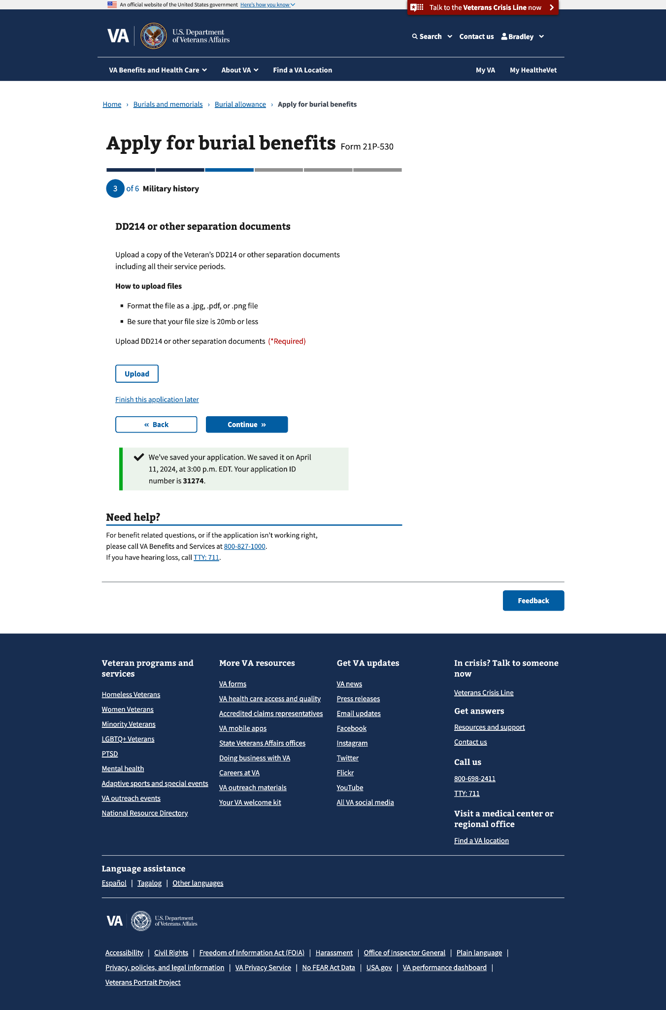

You can upload multiple documents:

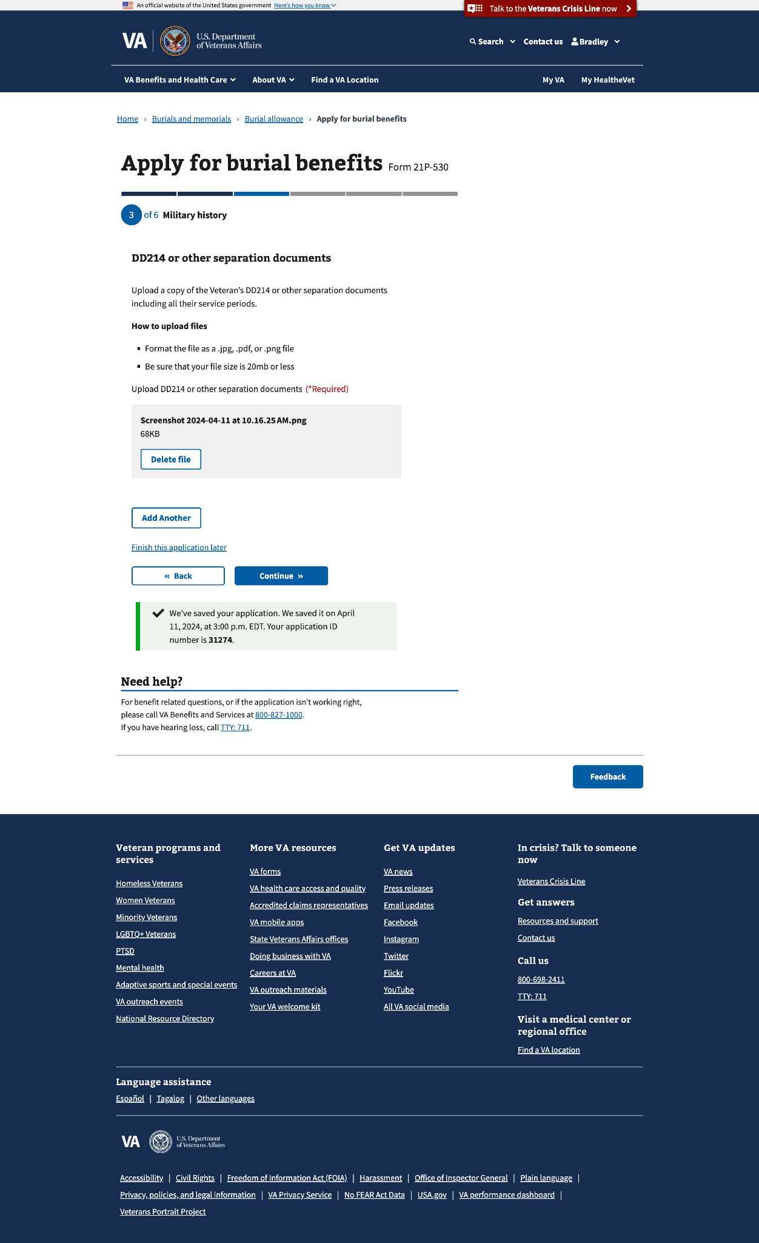

#### 3.2 Service periods

This page will appear if the claimant selects “No” to the “Do you want to upload a copy of the Veteran’s DD214 or other separation documents?” question on the previous screen.

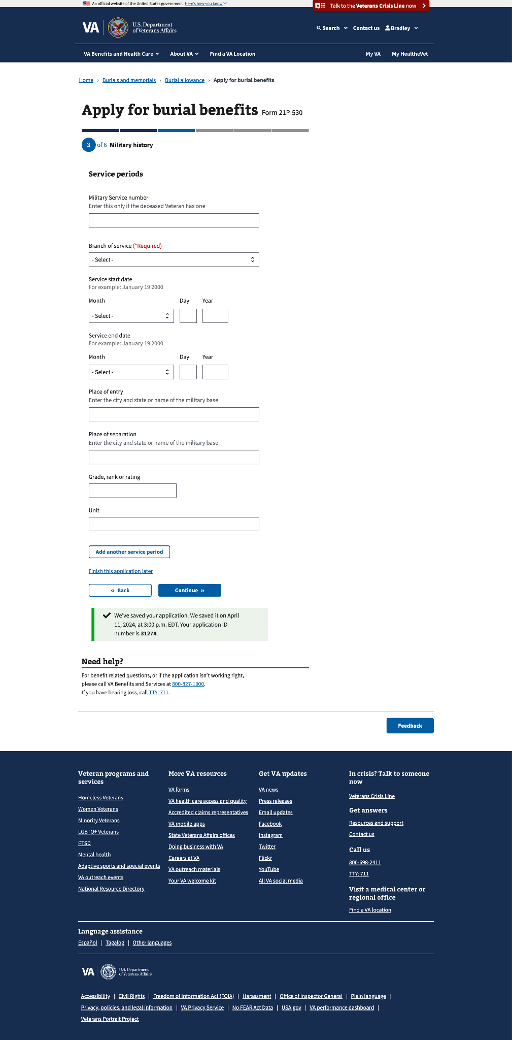

You can add multiple service periods:

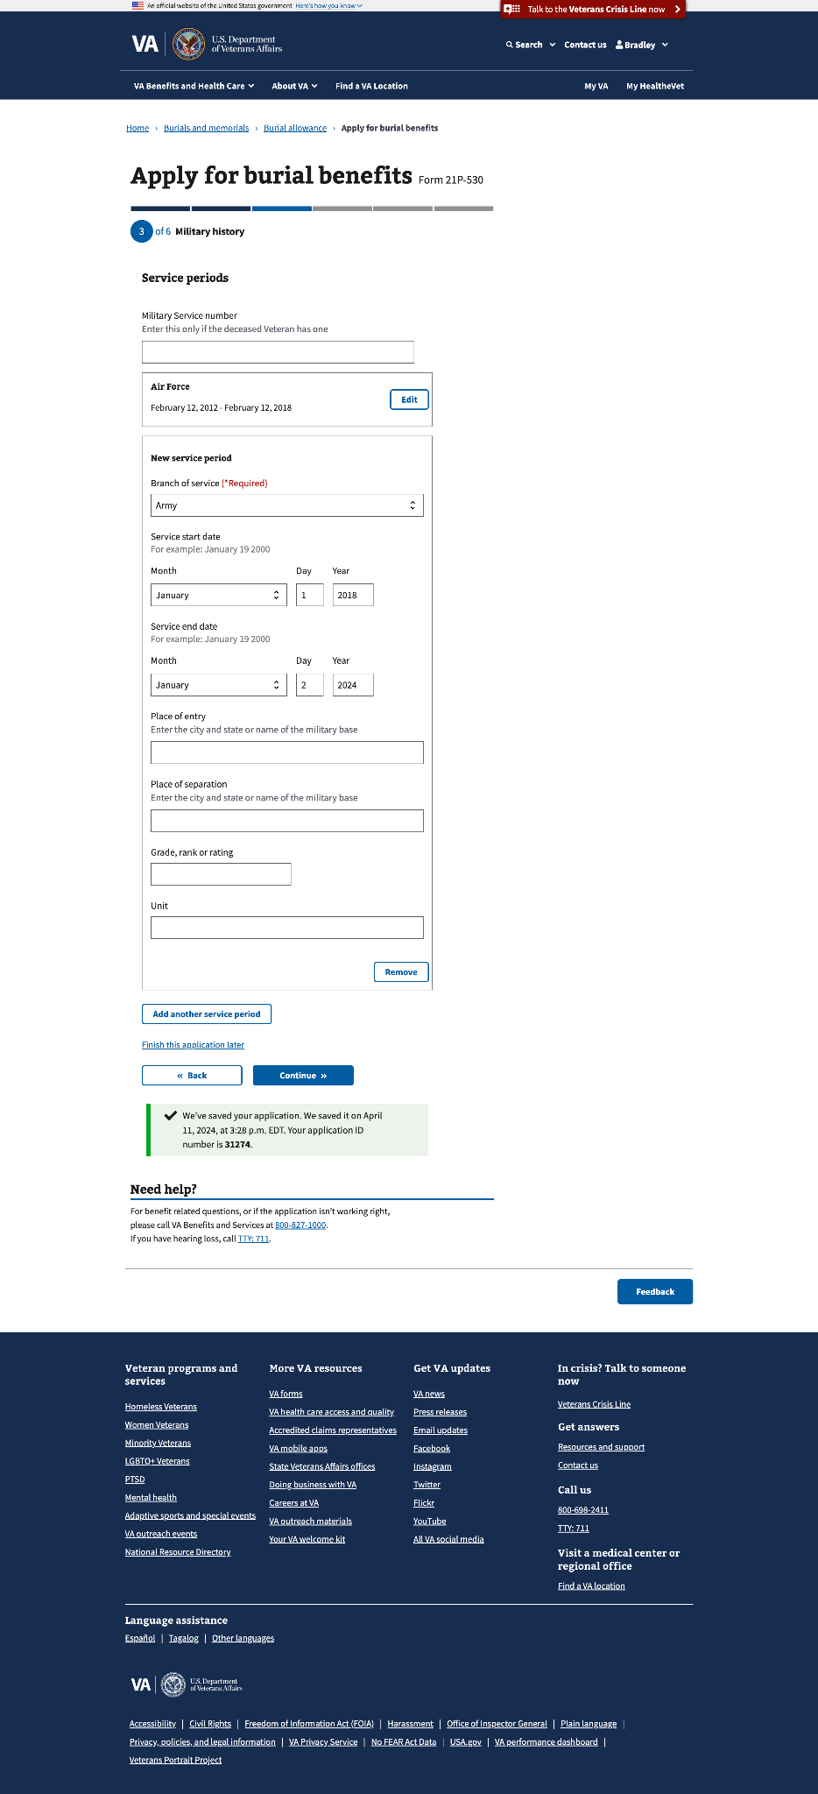

#### 3.3 Veteran’s previous names

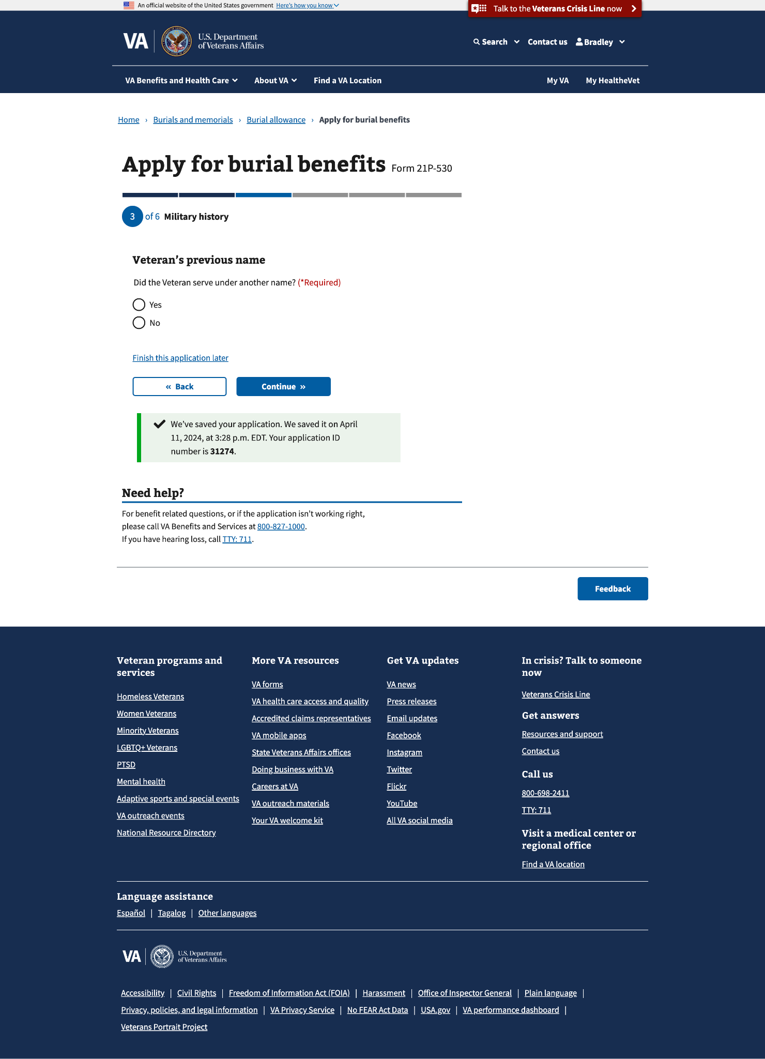

#### 3.4 Add Veteran’s previous name

This page will appear if they select “Yes” to the “Did the Veteran serve under another name?” question on the previous screen.

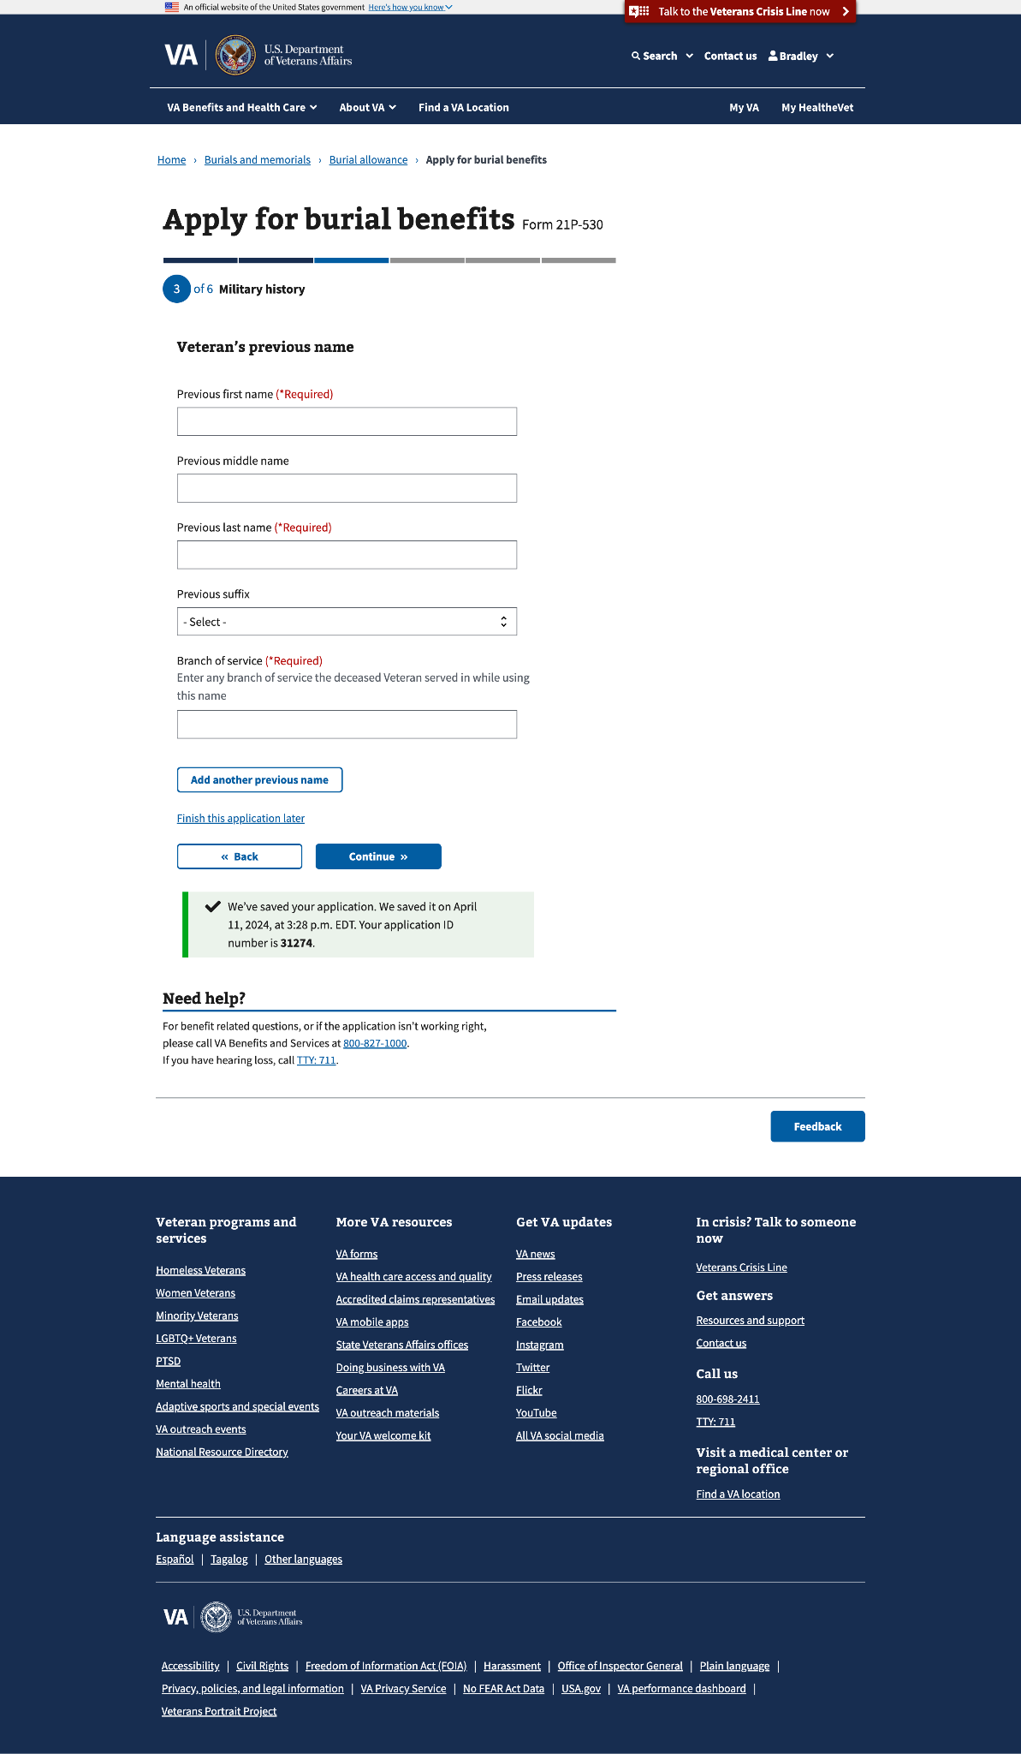

You can add multiple previous names:

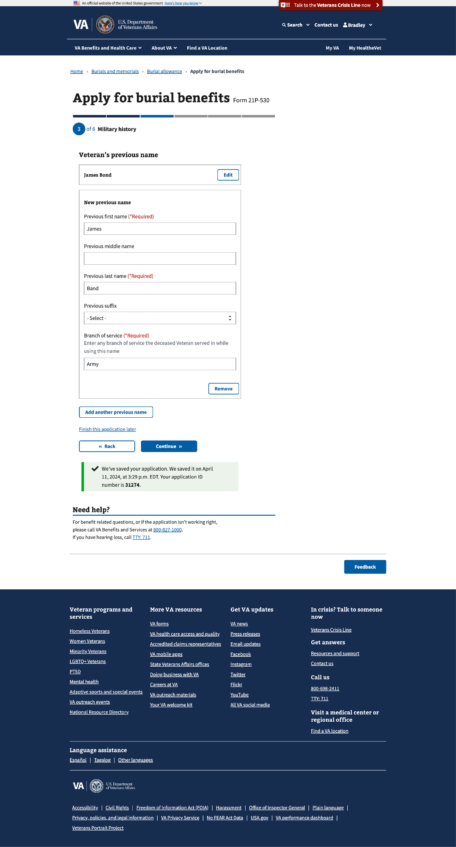

### Step 4: Benefit Selection

This step can have up to 9 sub-pages, depending on the allowances for which the claimant  
is applying:

* Burial and funeral costs
* Costs for the plot (gravesite) or interment
* Transportation costs of transporting the Veteran’s remains to the final resting place

#### 4.0 Costs you paid for

Based on the selection(s) on this page, there may be several pages that the claimant will have to go through.

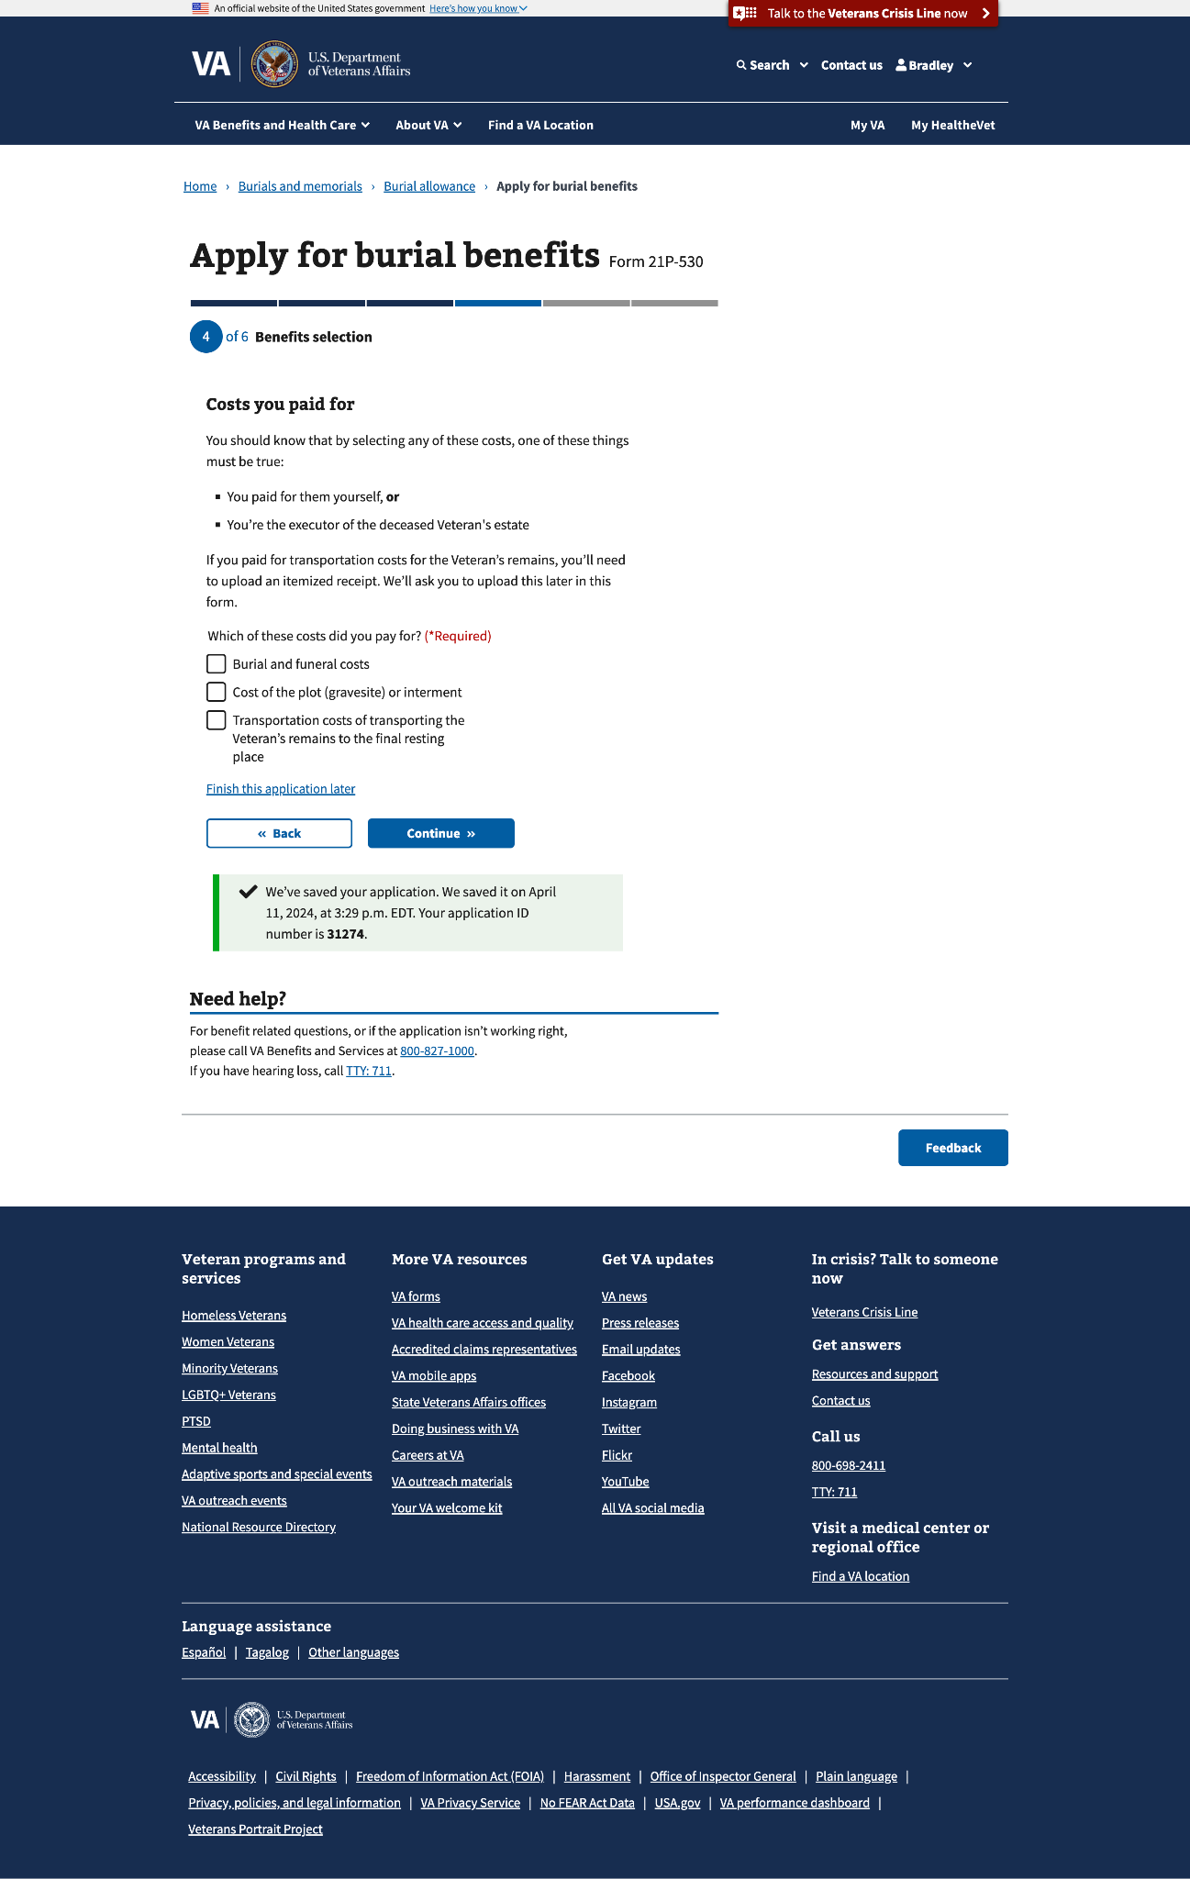

#### Burial and funeral costs

This benefits selection could render up to 3 sub-pages.

##### 4.1 Burial allowance

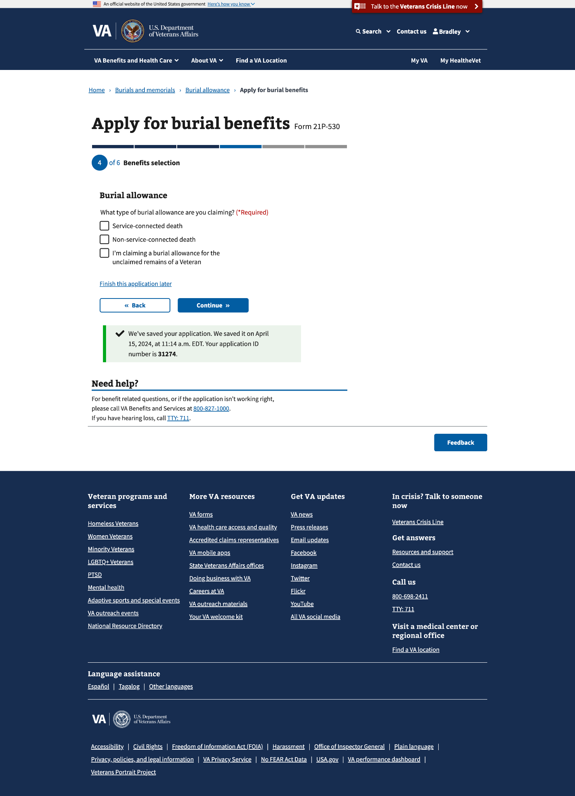

##### 4.2 Type of burial allowance

If “I’m claiming a burial allowance for the unclaimed remains of a Veteran” (last option) is selected, a new page will appear with a statement that needs to be confirmed by the claimant.

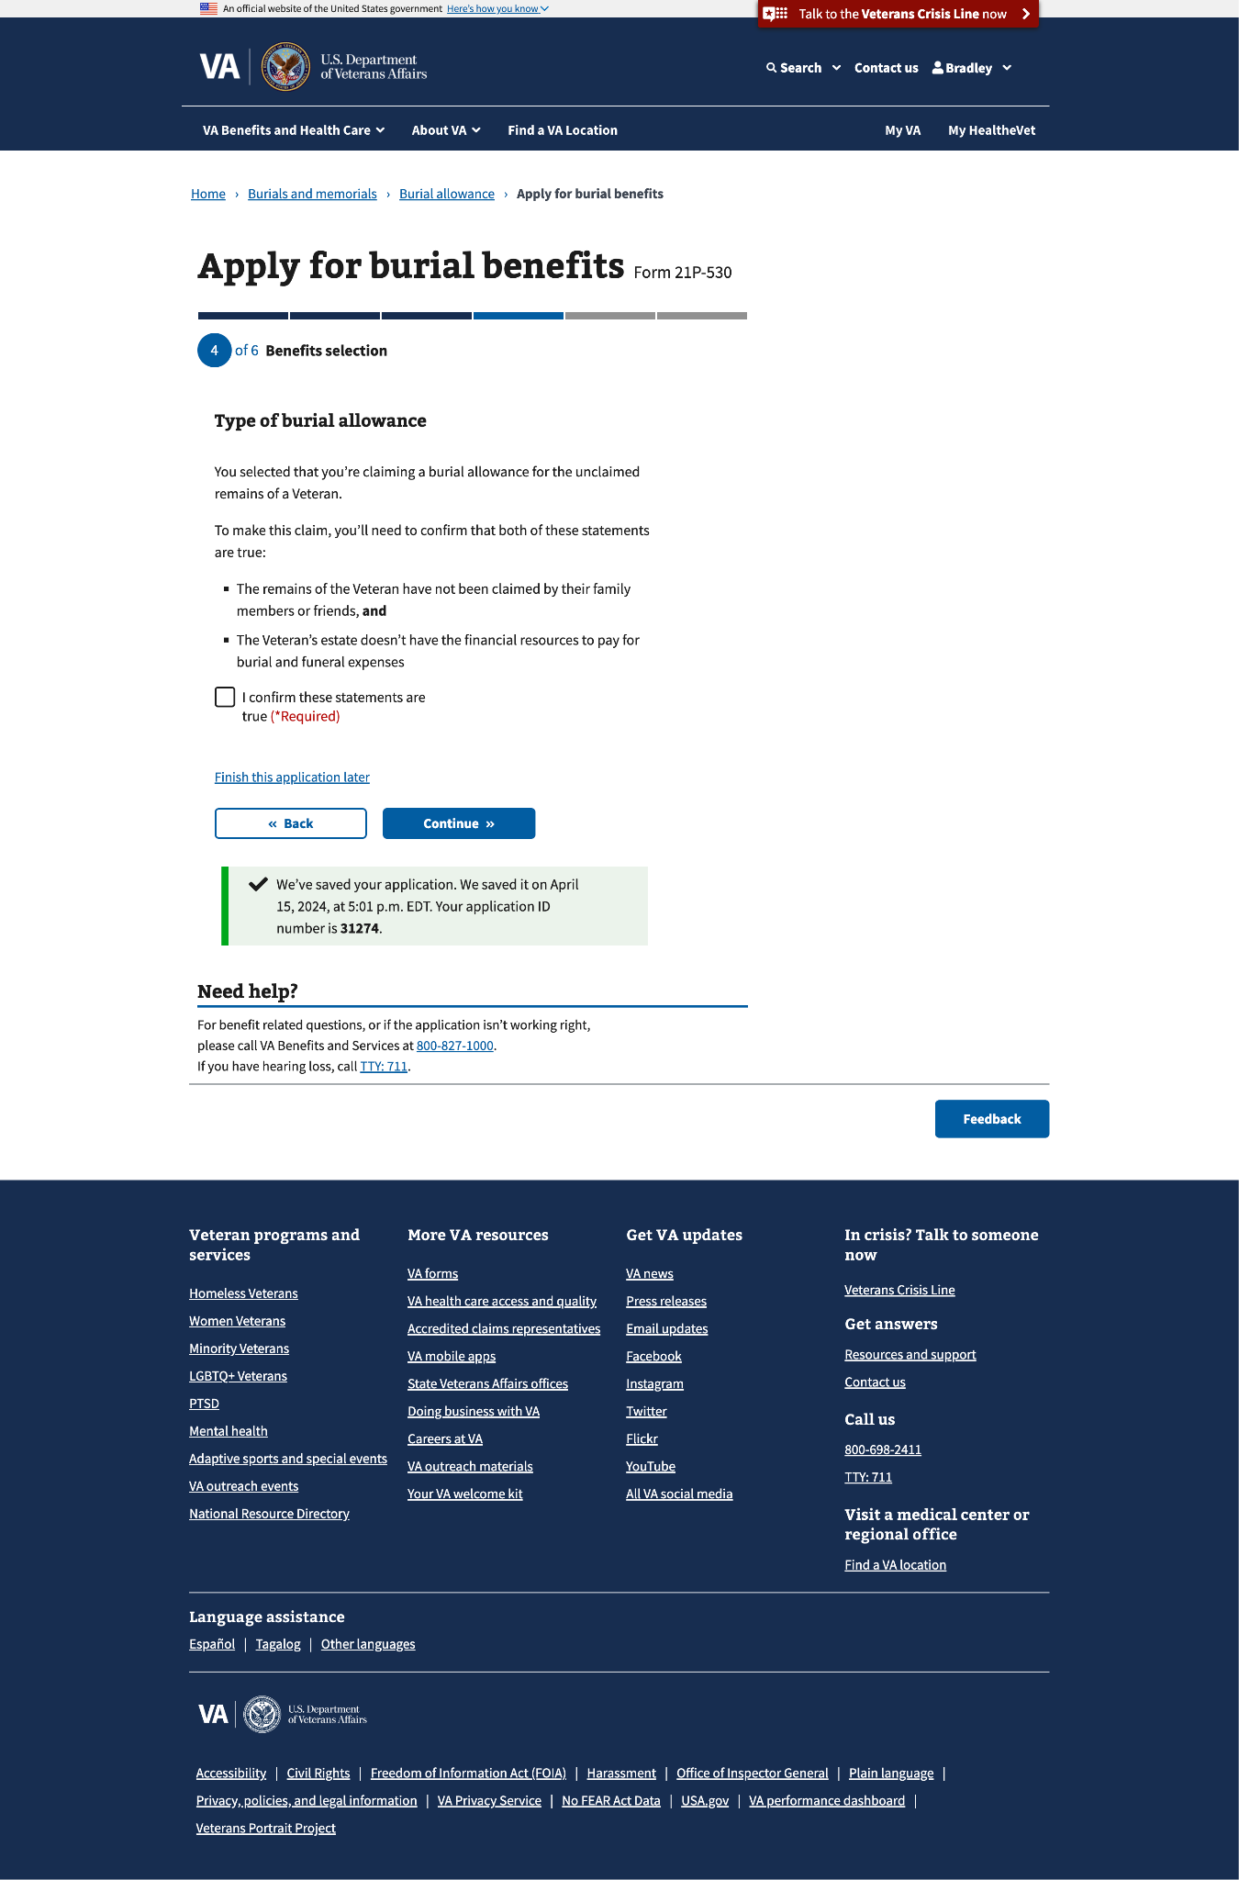

##### 4.3 Burial allowance (continued)

#### 

#### Cost of the plot (gravesite) or interment

This benefits selection could render up to 6 sub-pages.

##### 4.4 Final resting place

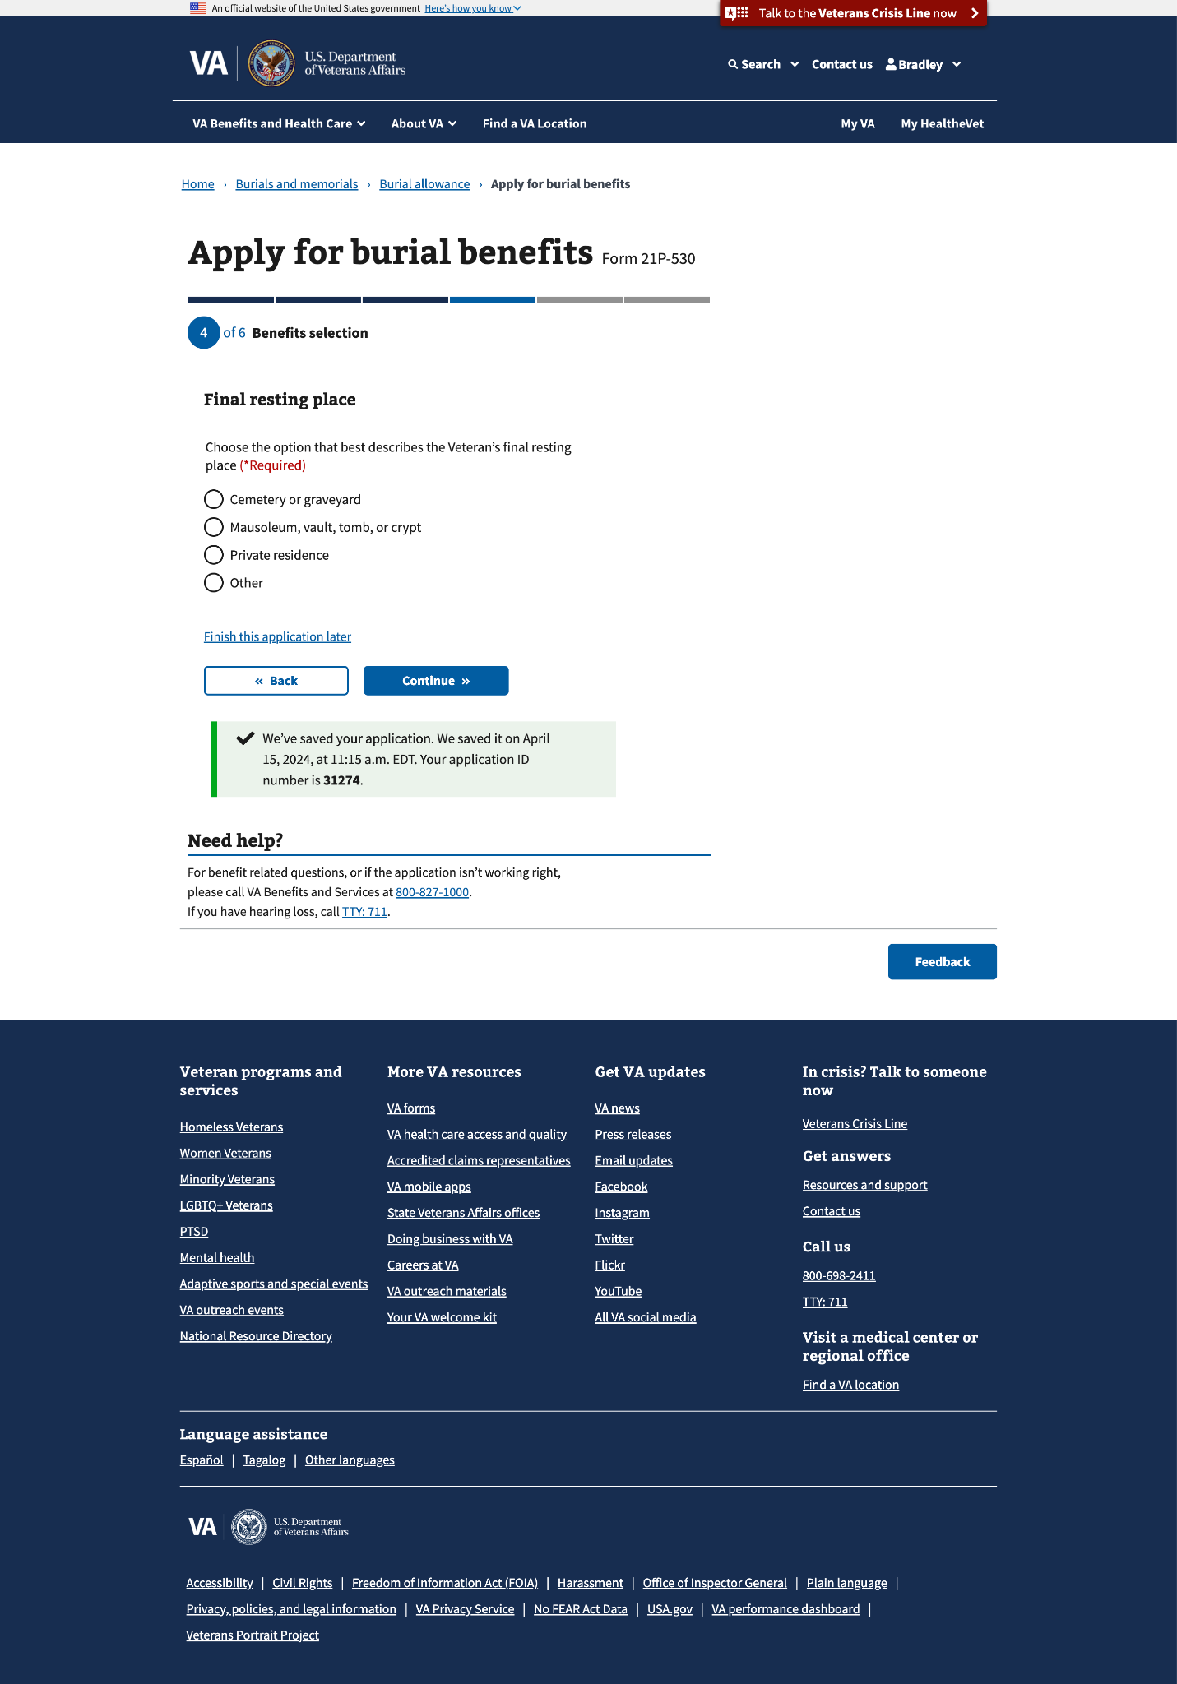

If “Other” is selected, a conditional field will appear to specify the final resting place of the deceased Veteran’s remains.

#### 

#### 

##### 4.5 Cemetery location

##### 

If “Yes” is selected, a conditional field will appear to specify the name of the cemetery.

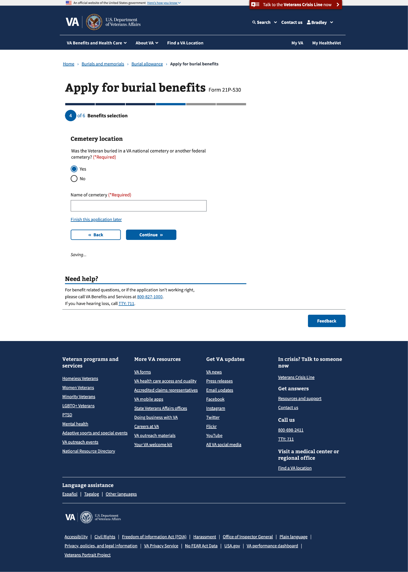

##### 4.6 Cemetery location (continued)

#### 

##### 4.7 Cemetery location (continued)

If either “Yes, in a state cemetery” or “Yes, on a tribal trust land” is selected a new page will appear, where the claimant needs to specify the name and zip code of either the state cemetery or tribal trust land.

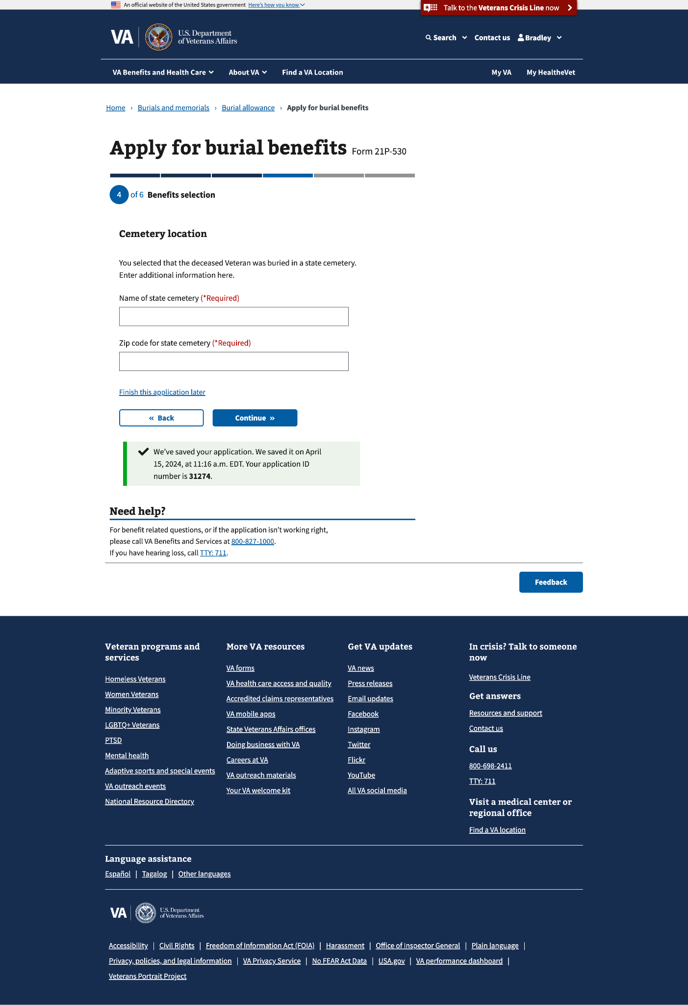

##### 4.8 Plot or interment allowance

##### 

If “Yes” is selected, the claimant will need to provide the amount the government or employer paid.

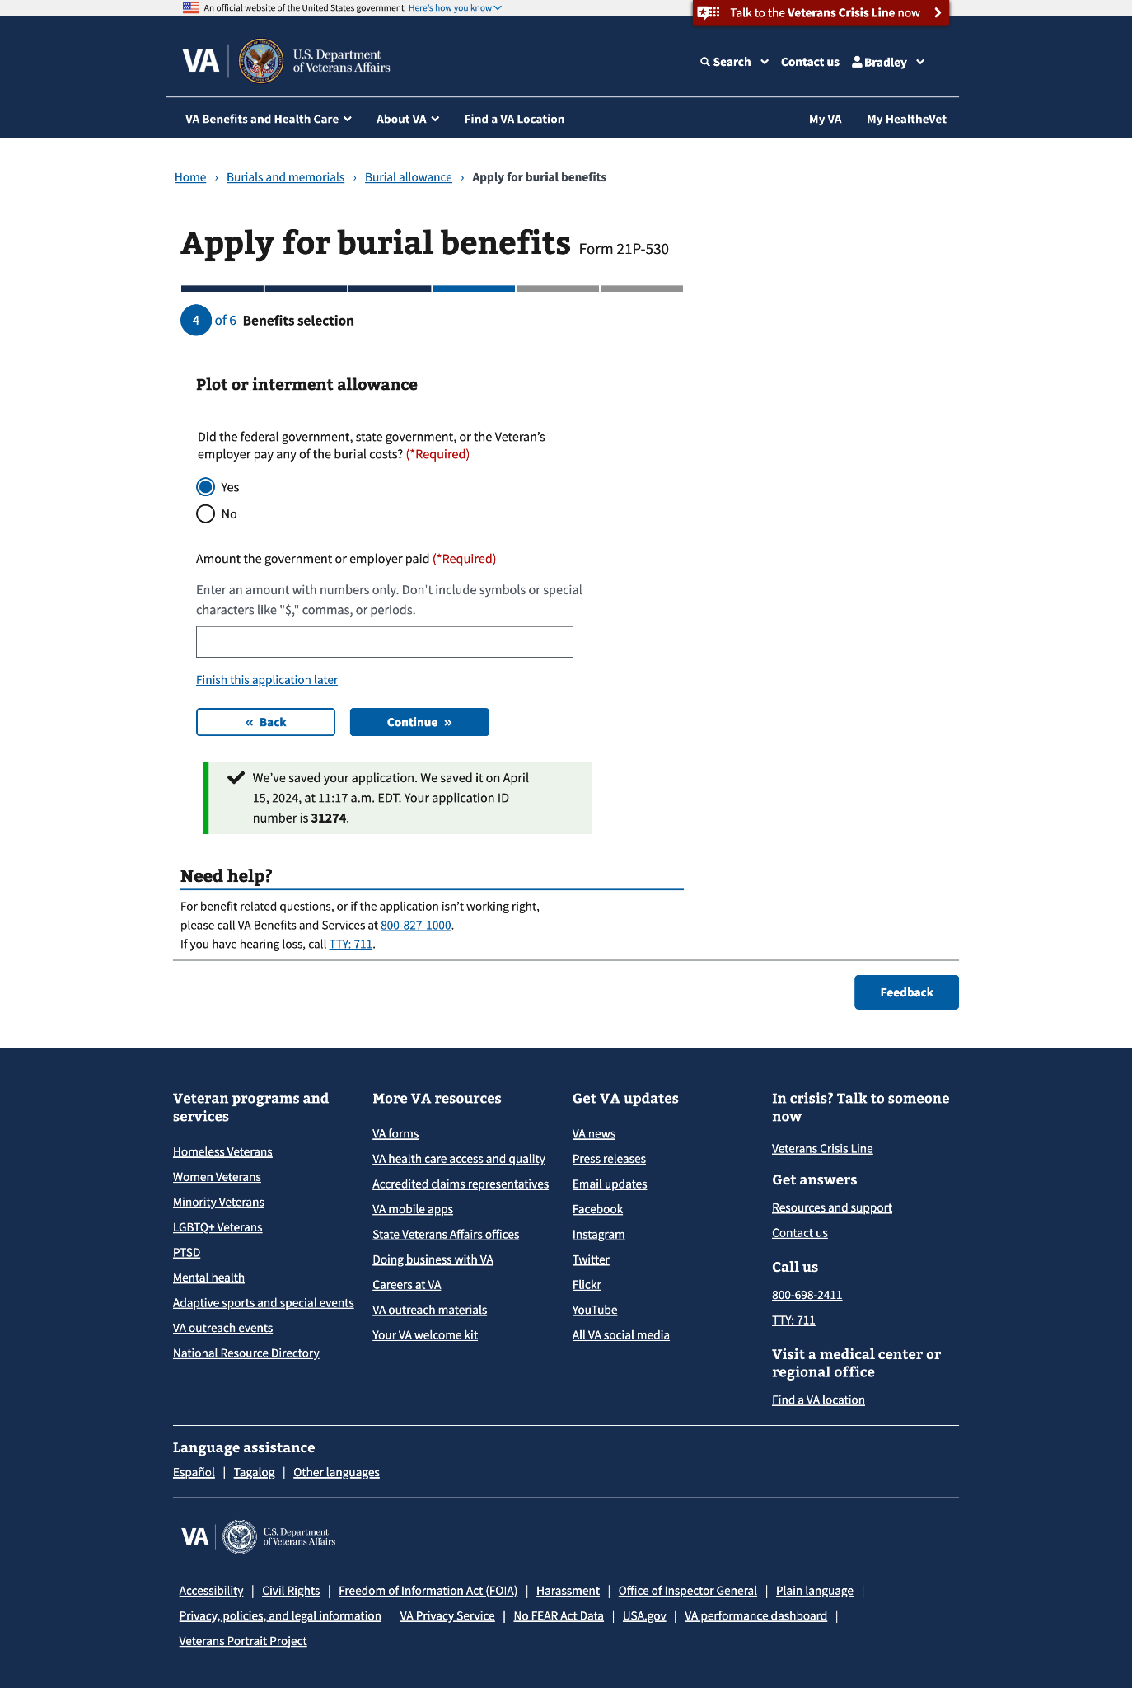

##### 4.9 Plot or interment allowance (continued)

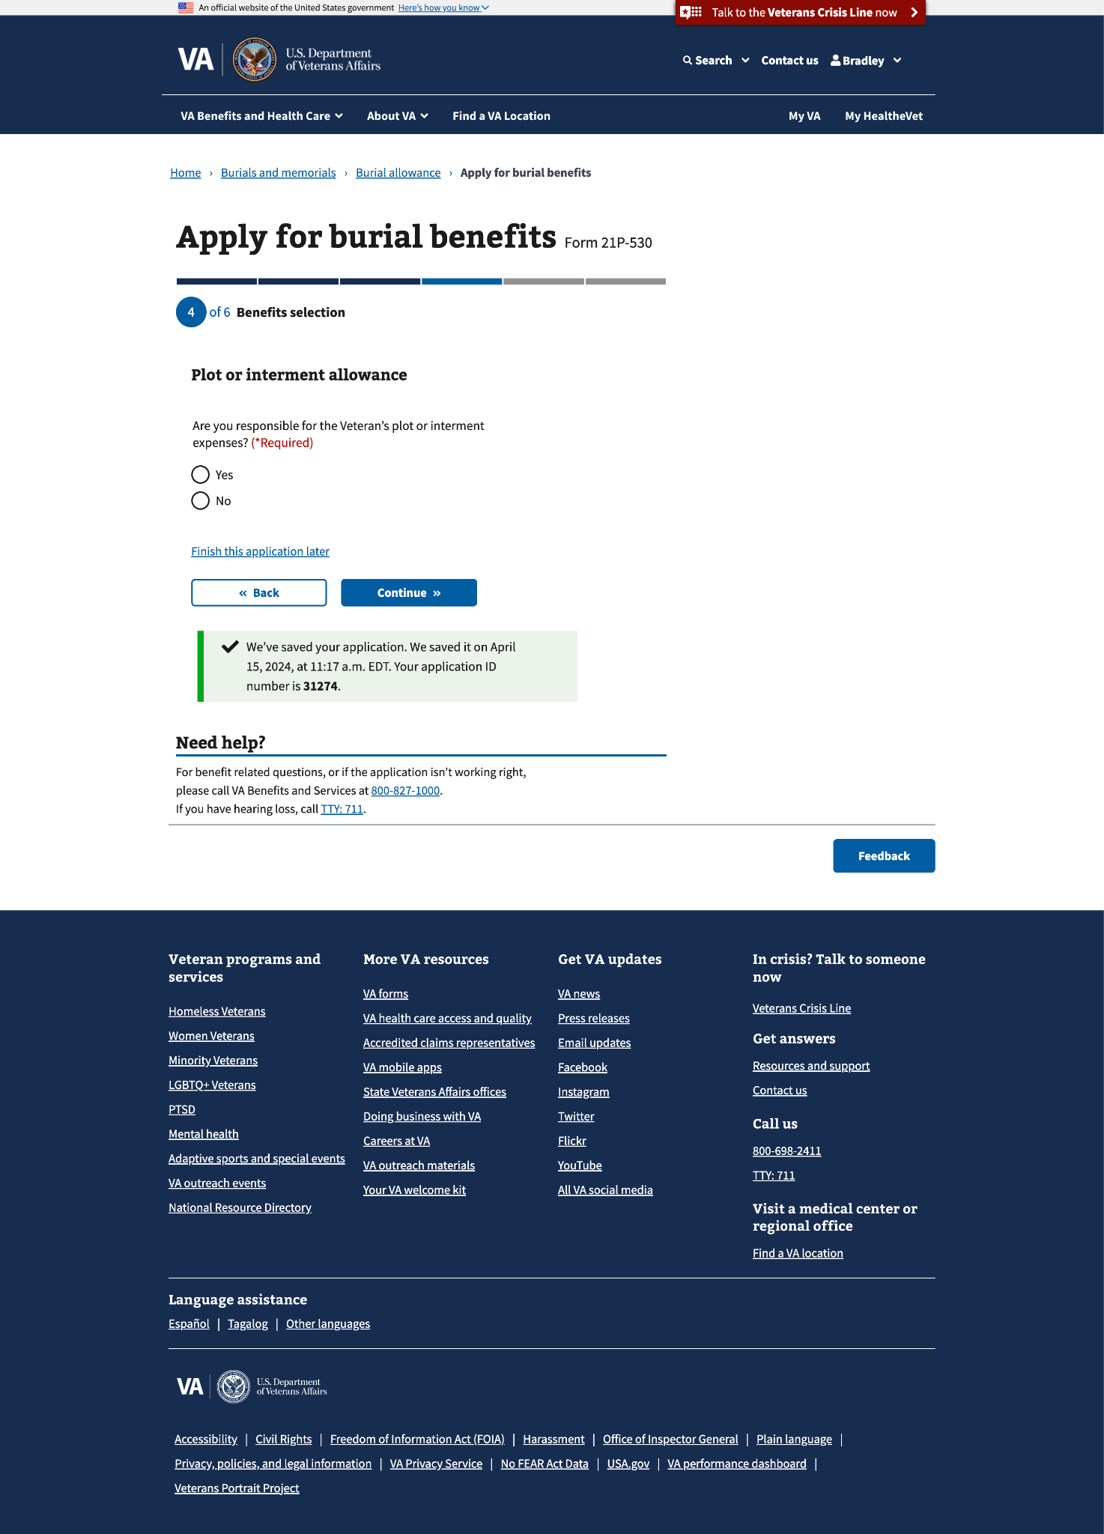

#### 4.10 Transportation costs

### 

### Step 5: Upload documents

This step can have up to 3 sub-pages that ask the claimant to upload the Veteran’s death certificate, transportation costs (if they selected to apply for this allowance), and any additional documents.

#### 5.0 Death certificate

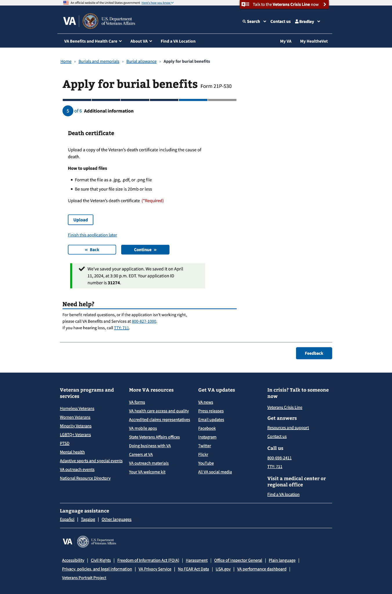

You can upload more than one.

#### 

#### 5.1 Transportation costs

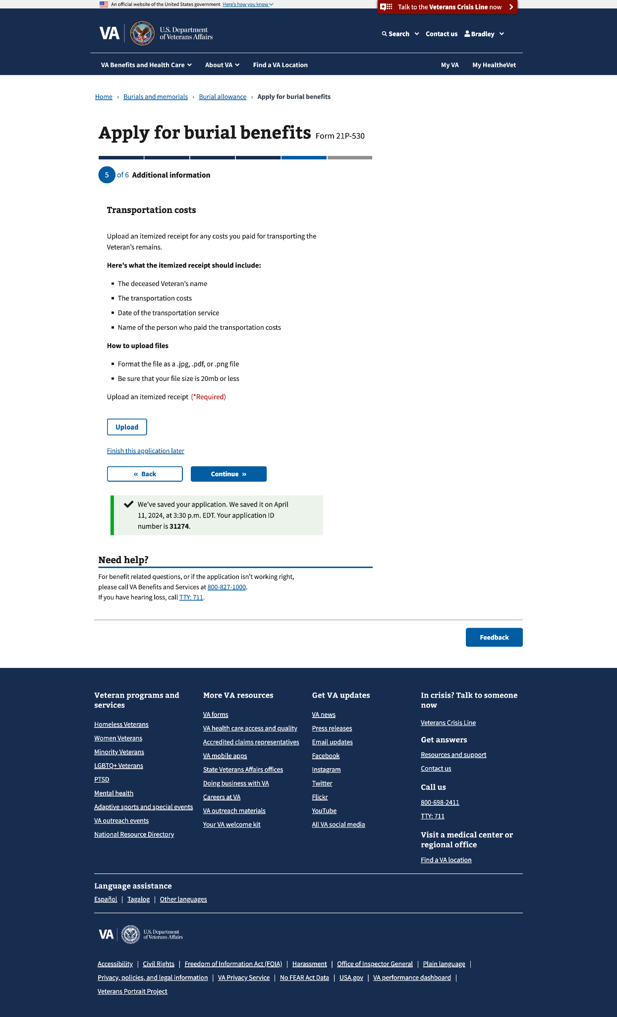

You can upload more than one.

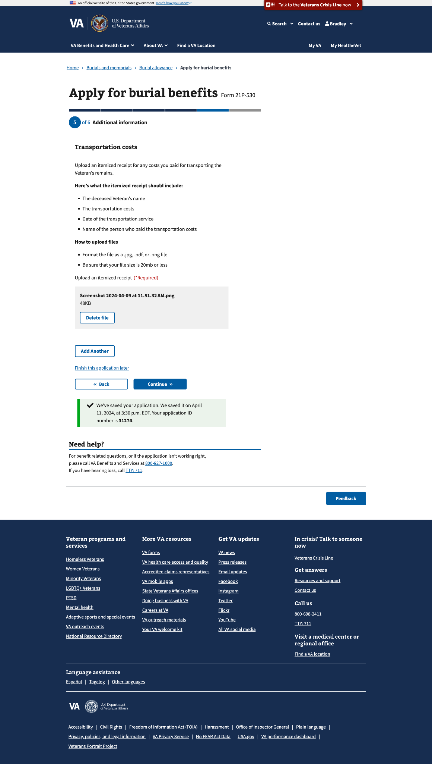

#### 

#### 5.3 Additional evidence

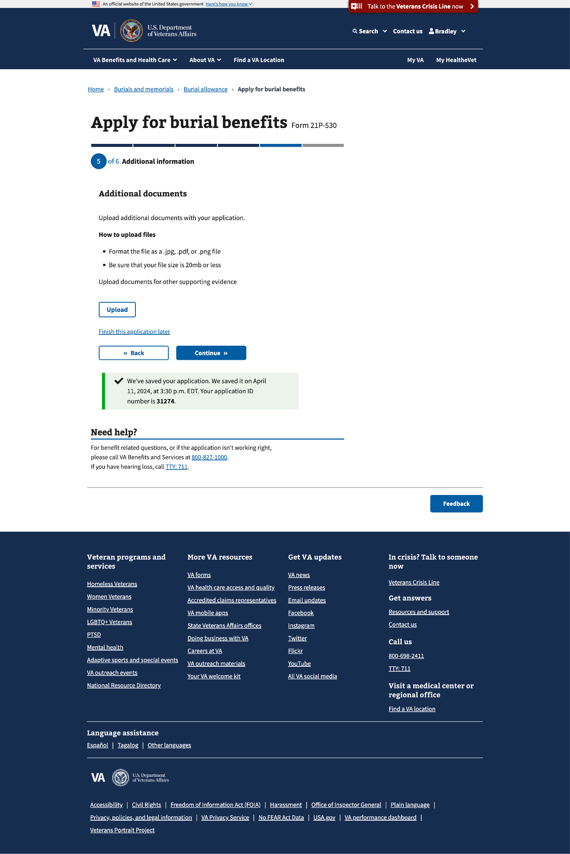

You can upload multiple documents.

#### Faster claim processing

#### 

### Step 6: Review

In this step, the claimant can review all the information entered, edit sections, and submit the application.

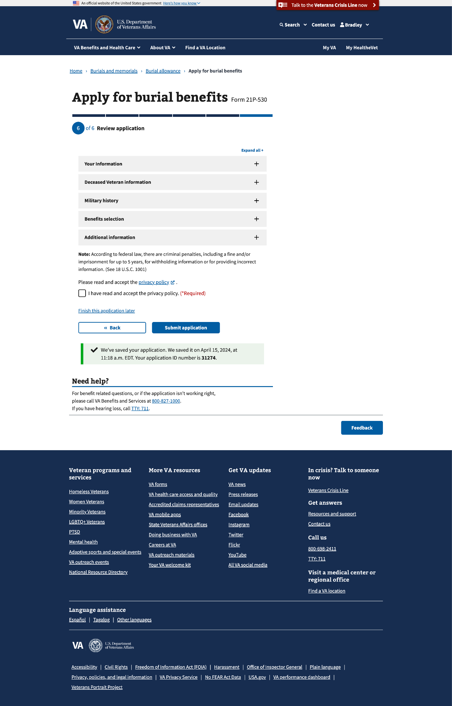

### 

### Confirmation

After the claimant submits this form, they will view a confirmation page that lists the following: Who submitted the form, confirmation number, date submitted, deceased Veteran, benefits claimed, documents uploaded, and the Pension Management Center to which it was sent.

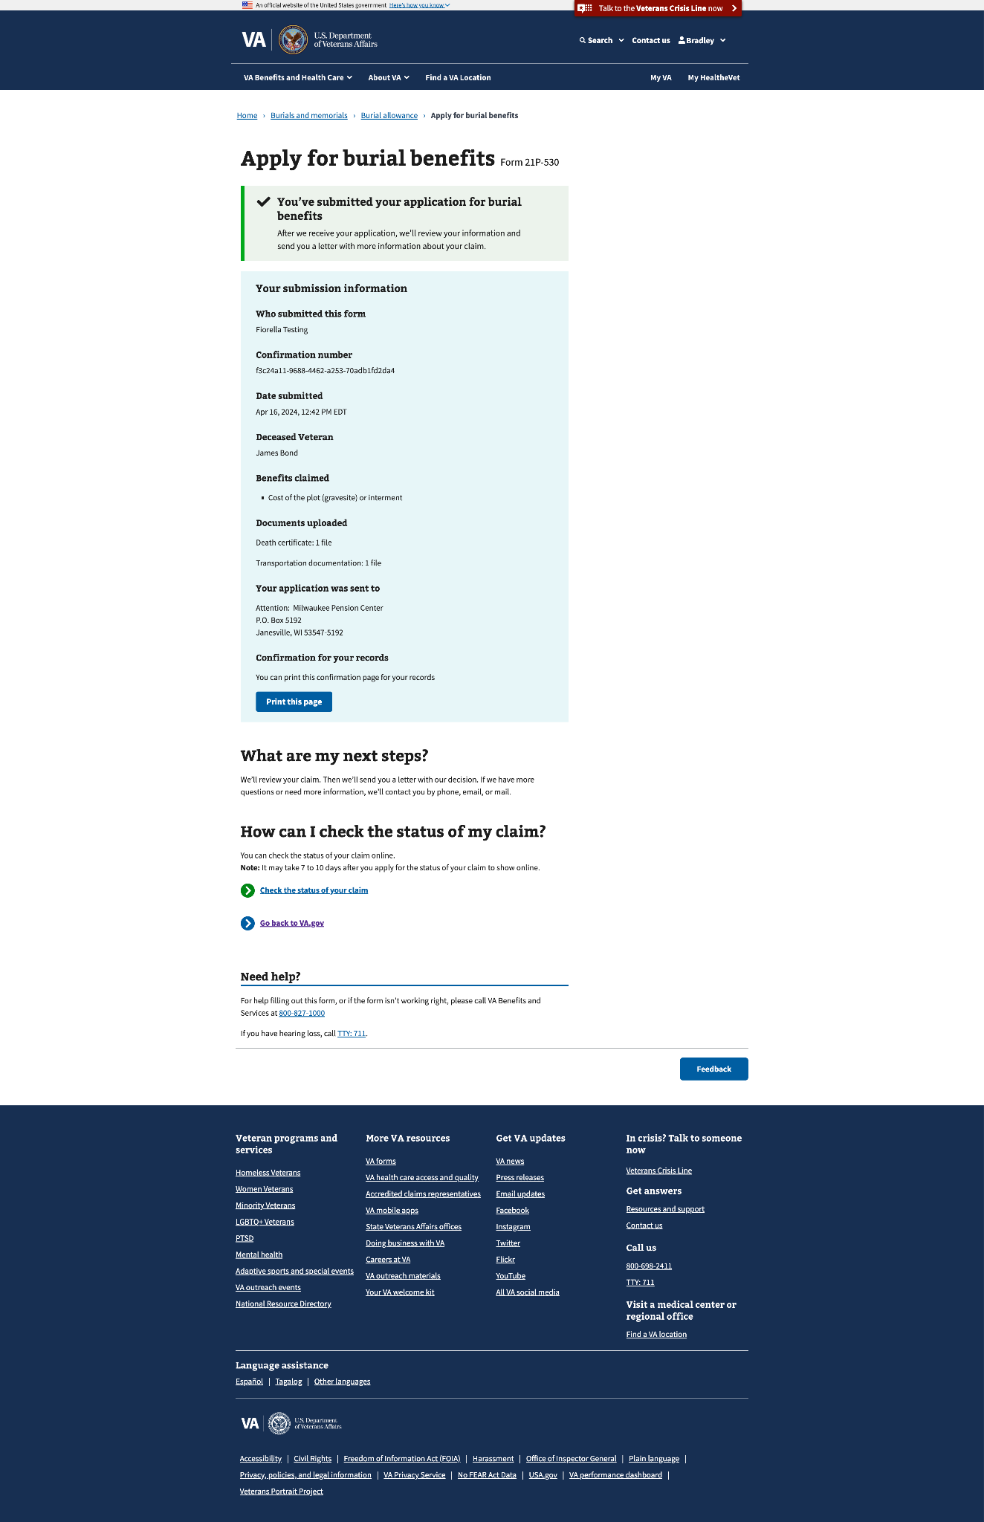

### Email confirmation

The claimant will also receive the information on the confirmation page as an email.

## 5. Major Issues and Error Messages

#### Required response

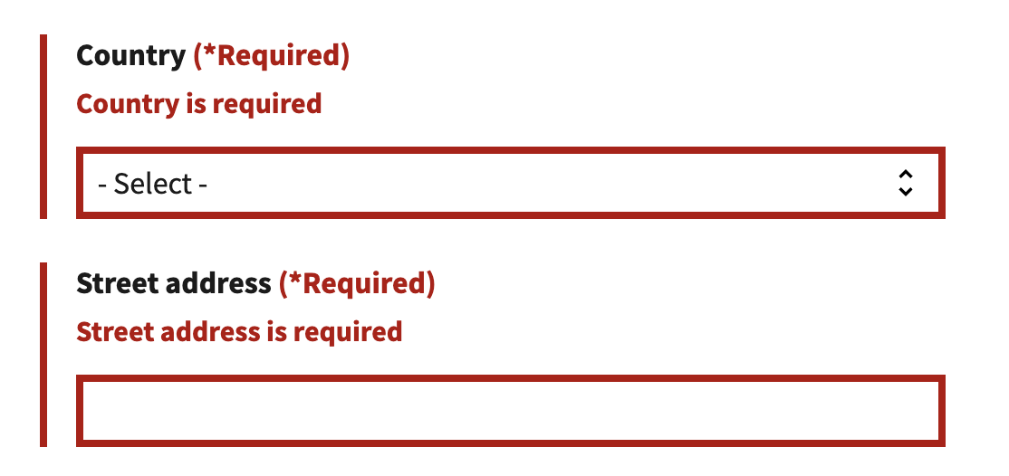

#### Privacy policy

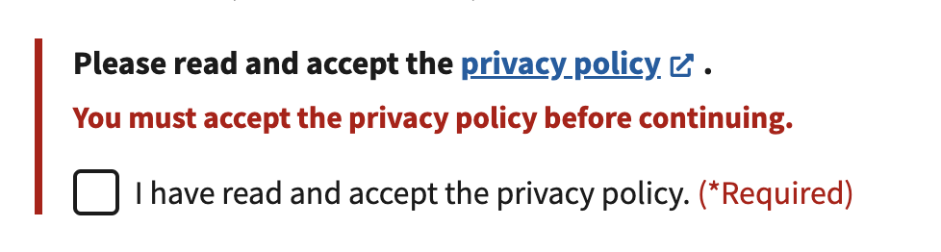

#### Missing information

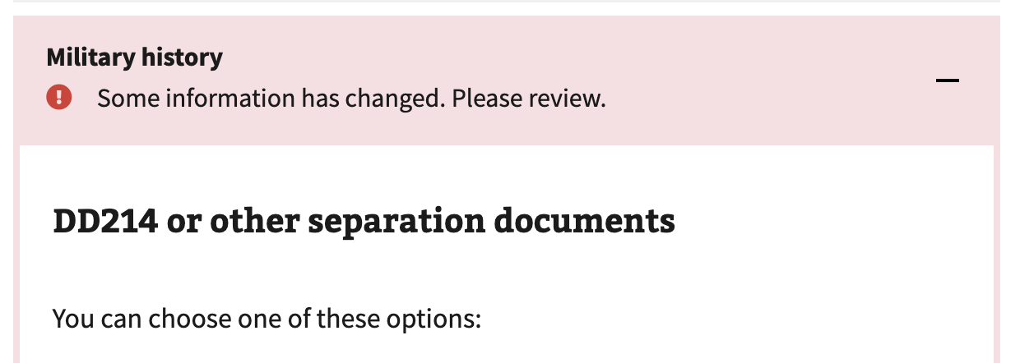

#### Submission failure

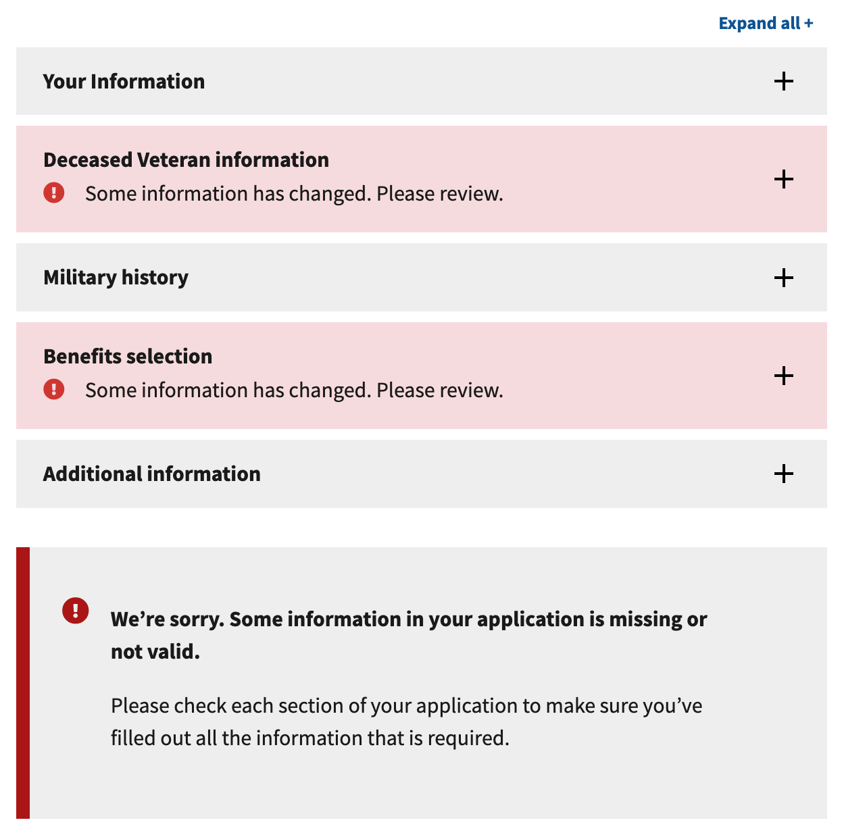

#### Connection error

